|  |  |
| --- | --- |
| A picture of a winding road and trees  Hermes Library  S3879954 – Software Engineering Student | Abstract  A web project for assignment 1 in Web Programming course  Nhung Tran – s3879954@rmit.edu.vn  RMIT University - COSC2430 |

I. Introduction 2

General Scope 2

II. Project Description 2

A. Describe Features 2

B. What I’ve Learned 3

III. Implementation Details 3

A. Design Decision 3

B. Technical Details 4

IV. Screenshots 5

A. Features Have Done 5

B. Features Have Not Done 5

C. Bonus Feature 5

D. Bugs 5

V. Conclusion 6

VI. Reference 6

VII. Appendix 6

A. Appendix 1 6

B. Appendix 2 17

C. Appendix 3 29

D. Appendix 4 37

E. Appendix 5 43

F. Appendix 6 51

Table of Appendix

Appendix 1 1. Homepage - Desktop design - 1 6

Appendix 1 2. Homepage - Desktop design - 2 7

Appendix 1 3. Homepage - Desktop design – 3 7

Appendix 1 4. Homepage – iPad Air design – 1 8

Appendix 1 5. Homepage – iPad Air design – 2 9

Appendix 1 6. Homepage – iPad Air design – 3 10

Appendix 1 7. Homepage – iPhone 12 Pro design – 1 11

Appendix 1 8. Homepage – iPhone 12 Pro design – 2 12

Appendix 1 9. Homepage – iPhone 12 Pro design – 3 13

Appendix 1 10. Homepage – iPhone 12 Pro design – 4 14

Appendix 1 11. Homepage – iPad Air design – Navigation Bar 15

Appendix 1 12. Homepage – iPhone Pro 12 design – Navigation Bar 16

Appendix 2 1 Category page - Desktop - 1 18

Appendix 2 2 Category page - Desktop - 2 18

Appendix 2 3 Category page - Desktop - 3 19

Appendix 2 4 Category page - Desktop - 4 19

Appendix 2 5 Category page - Desktop – 5 20

Appendix 2 6 Category page – iPad Air – 1 21

Appendix 2 7 Category page – iPad Air – 2 22

Appendix 2 8 Category page – iPad Air – 3 23

Appendix 2 9 Category page – iPad Air – 4 24

Appendix 2 10 Category page – iPhone 12 Pro – 1 25

Appendix 2 11 Category page – iPhone 12 Pro – 2 26

Appendix 2 12 Category page – iPhone 12 Pro – 3 27

Appendix 2 13 Category page – iPhone 12 Pro – 4 28

Appendix 2 14 Category page – iPhone 12 Pro – 5 29

Appendix 3 1 Book Detail page - Desktop - 1 30

Appendix 3 2 Book Detail page - Desktop - 2 30

Appendix 3 3 Book Detail page - Desktop - 3 31

Appendix 3 4 Book Detail page – iPad Air- 1 32

Appendix 3 5 Book Detail page – iPad Air- 2 33

Appendix 3 6 Book Detail page – iPad Air - 3 34

Appendix 3 7 Book Detail page – iPhone Pro 12 - 1 35

Appendix 3 8 Book Detail page – iPhone Pro 12 – 2 36

Appendix 3 9 Book Detail page – iPhone Pro 12 - 3 37

Appendix 4 1 Contact page - Desktop -1 38

Appendix 4 2 Contact page - Desktop -2 38

Appendix 4 3 Contact page - Desktop -3 39

Appendix 4 4 Contact page – iPad Air -1 40

Appendix 4 5 Contact page – iPad Air -2 41

Appendix 4 6 Contact page – iPhone 12 Pro -1 42

Appendix 4 7 Contact page – iPhone 12 Pro -2 43

Appendix 4 8 Contact page – iPhone 12 Pro -3 44

Appendix 5 1 About Us Page - Desktop -1 45

Appendix 5 2 About Us Page - Desktop -2 45

Appendix 5 3 About Us Page - Desktop -3 46

Appendix 5 4 About Us Page – iPad Air -1 47

Appendix 5 5 About Us Page – iPad Air -2 48

Appendix 5 6 About Us Page – iPhone Pro 12 -1 49

Appendix 5 7 About Us Page – iPhone Pro 12 -2 50

Appendix 5 8 About Us Page – iPhone Pro 12 -3 51

Appendix 6 1 Privacy Page - Desktop - 1 53

Appendix 6 2 Privacy Page - Desktop - 2 53

Appendix 6 3 Privacy Page – iPad Air - 1 54

Appendix 6 4 Privacy Page – iPad Air - 2 55

Appendix 6 5 Privacy Page – iPhone 12 Pro - 1 56

Appendix 6 6 Privacy Page – iPhone 12 Pro - 2 57

Appendix 6 7 Terms Page – Desktop - 1 58

Appendix 6 8 Terms Page – Desktop - 2 58

Appendix 6 9 Terms Page – iPad Air - 1 59

Appendix 6 10 Terms Page – iPad Air - 2 60

Appendix 6 11 Terms Page – iPhone Pro 12 - 1 61

Appendix 6 12 Terms Page – iPhone Pro 12 - 2 62

Appendix 6 13 Copyrights Page – Desktop - 1 63

Appendix 6 14 Copyrights Page – Desktop - 2 63

Appendix 6 15 Copyrights Page – iPad Air - 1 64

Appendix 6 16 Copyrights Page – iPad Air - 2 65

Appendix 6 17 Copyrights Page – iPhone 12 Pro - 1 66

Appendix 6 18 Copyrights Page – iPhone 12 Pro - 2 67

# Introduction

The website 'Hermes Library Website' is a book trading website. Using this website, the users can find and buy their books, or selling if they want to sell their books. The main purpose of this website is to bring the books globally, so that the book lovers can reach and exchange the books from anywhere and anytime they want.

## General Scope

Technically, this project concentrates on frontend instead of developing backend. The primary purpose of buiding this project is to reinforce the knowledge of html, and plain css, especially styling responsive and animation in this website. Besides, this project aims to let the coders understand the importance of using javascript and dynamic program in developing the website. Finally, this project aims to help the web coders who are in beginner level improve their CSS skills and using tags inside HTML file. After this project, they are expected to be able to write CSS and HTML fluently and understanding clearly why applying JavaScript to web programming.

In this project, there are several requirements, including using plain HTML and CSS to style and add animation, having responsive design, having 4 compulsory types of pages with specific requirements for each page, et cetera. Therefore, in this project, for Home, Category, there are book list displayed to the users categorized following its category. On the other hand, in Book Detail page, the users can view the book information in details with images and description. In Contact page, there is a form to input the contact information if the users want to buy or sell books. In other pages, including About, Privacy, Terms, and Copyrights, the users can understand clearler about the webite company and its policy. Finally, all pages are styled with animation when hovering, and include responsive design – mobile, tablet, and desktop.

However, because the objectives of this project concentrate on the improvement of using HTML and CSS, there is no backend for this project. In other words, the users can only view the book list, the Contact form information will not be sent to the client. And all `Add to cart` buttons in Detail page will only display a message modal. The main resources in this project are HTML, CSS, and some JavaScript for animation control.

This project lasts for 4 weeks. The first week is for researching, the second week is for designing, and two final weeks are for implementing this project.

# Project Description

## Describe Features

There are couple of features: view list of books which are categorized following its categories, sub-categories, navigate between pages, input contact form, and header images to recognize which websites the users are in. Inside Navigation bar, the users can navigate to a specific Category page and Contact page. While in footer, the user can navigate to Privacy, Terms, Copyrights, and About Us pages to understand more about this website. Not only that, but the users can also mail directly to the website author at the end of footer if they have any urgent problems.

Inside the Homepage, the users not only can view the categorized books, but they can also watch the videos about book reviews so that they can decide which books to buy easier. There is also a header image at the beginning of the page displaying following message.

Inside the Category page, the users can navigate to each sub-category section, or they can navigate to Book Detail page as in Homepage. Inside the Book Detail page, the users can view all the books’ information, including book images, its price, name, authors, description. This book information can be also inside Homepage, and Category page in summary. The customers can also click `Add to cart` button, there will be a small modal notifying that they have added the book to cart successfully.

Inside Contact page, the users can fill in the Contact form, including their contact purpose, name, contact preference, et cetera. This contact form’s all inputs are in required fields, excepting for extra note input field. Therefore, if the users click submit without inputting one of those following required fields, there will be a message prompting the users to input. After inputting all required fields, and clicking submit button, there is a modal notifying user having been successfully submitted. Not only that, but the users can also delete all inputted information by clicking reset button.

Finally, responsive design is applied to all existing pages, and some of the components, including buttons, images, welcome header images inside Home and Category pages, contain animation when hovering or clicking. There is also difference in font family for titles, navbar elements to improve the users’ vision.

## What I’ve Learned

By implementing those features, I learned how to add animation delay and use CSS variables effectively to make the website more appealing, and eye-catching with animation in header welcome image. Besides, I learned how to use Flexbox and Grid, font size variables, sizing variables to implement responsive design. Inside navigation bar, I also learned how to add modal when in mobile screen and how to toggle that modal with hamburger button without using JavaScript.

Inside Contact page, I understood clearly how usable the types of input elements are, and how to apply these types of inputs to real life application. And how to style and create a modal when the users click on a button like ‘Add to cart’ inside Book Detail page or ‘Submit’ inside Contact form.

# Implementation Details

## Design Decision

**Color choosing**. Inside this project, to make the customers concentrate on the content, I choose `white`, `black`, and one random color, which is called ‘monochromatic compositions’ [1]. In this case, that random color is `brown` color, because the books are made of wood, so that the customers can memorize the role of the trees in helping bring the wisdom to humanity. Besides, I did not use plain `white`, and `black`, instead, I used a bit yellowish white, and a bit brownish black color to suit with the `brown` color I chose.

**Font choosing**. I chose 4 fonts inside this project. One font is for header title of the page, one is for subtitle, one is for header for each section, and the final one is for the rest of the content. Three of them are handwritten fonts to suit with the books website subject.

Finally, I also decided to add header welcome image at the beginning of Home page and Category pages. I want to ensure the users to feel welcomed when they first come to my website, and they can know which category page they are in when they use the website.

## Technical Details

For navigation bar, I style the container with sticky position with space-between flex box stylings. The reason why I use sticky is because fixed position can hide a part of next section inside a body, while sticky does not affect next section’s body display until the users scroll the website. I also use flexbox to make the logo to the left, and nav content to the right. In mobile design, full navigation bar will be hidden, and there is only a logo and a hamburger button to toggle the sidebar. In responsive design, I challenge myself by using checkbox input element to toggle the navigation sidebar menu. The button is put inside the label, while its checkbox input is hidden. When the users click on the hamburger button, the label toggles the checkbox input. When input is marked as checked, the menu displays with the same content as the navigation bar in desktop version. For each nav element, I also add after pseudo element to have animation to improve the user experience when the users hover each element. (*Appendix 1 – main, 2, 3, 4, 5, 6*)

For footer section, this section is styled using flexbox, while in mobile responsive design, I change its flex direction from row to column. There are 2 main sections inside this footer: my contact information elements, and other page links. All links navigate the users to new tab, and each links have its own animation when the users hover the elements. (*Appendix 1 – main, 2, 3, 4, 5, 6*)

For displaying sections inside pages’ content, I use flexbox to have synchronous gap between sections instead of applying margin or padding to each element, so that I can modify the sizes easier for responsive styling. (*Appendix 1,2,3,4,5,6*)

For each section inside Home, and Category pages, I use flexbox to style the header title and the cards container easy. All those sections use the same class name called ‘cards’ to have the synchronous design. While inside the card container, I use grid to style the width of each card, so that I style inside the container itself instead of style inside the children. And this way helps me be able to concentrate on suitable size for each card for each breakpoint. To view all the books inside the section, I also apply overflow-scroll to view all the books horizontally. *(Appendix 1 - Homepage, 2 – Category page)*

For each book card in all pages, I use the same style with the same class name. Inside each card, I style content with flex box and column direction. I also have a button to navigate to book detail page with animation when hovering. *(Appendix 1 - Homepage, 2 – Category page)*

Specifically, inside the Homepage, the section to display rich medias are styled with flexbox and space between. And rich medias are embedding elements, which are taken from Youtube videos [2]. Not only that, but users can also click the Category title to navigate to the Category pages. *(Appendix 1)*

The category pages are styled the same as homepage, excepting for its content and the users cannot click its sub-category to navigate to new pages. *(Appendix 2)*

Inside Book Detail pages, the general structure is the same as other pages. However, the component and its content are different. There are 2 main sections: image section, and detail section. In image section, I use grid to style 4 images, price, and button. The reason why I choose grid is that I can rearrange all images easier inside responsive content. In detail section, I display the content using flex box with flex-start, and column direction to display. *(Appendix 3)*

Inside Contact page, I have two main sections with row direction styling using flexbox. One section is for displaying illustration images, and one section for storing form content. Inside form content, for each input, excepting for checkbox, radio inputs, and text area, I add the input name, and id, following withs its label using inputs’ id. To style the label and its input in the same line in desktop version, I use flexbox with row direction, while in mobile version, I change to column direction. I also implement 2 buttons, 1 for submit function and 1 for reset function. If users click the submit button, there is a modal popping up displaying submitted message. In contrast, if users click the reset button, all inputted values are clear. *(Appendix 4)*

For other pages, including Privacy, Copyrights, and Term pages, I use summary details elements to display each content section, while I use flexbox to display whole body content as other pages *(Appendix 6: 1 – 6: Privacy Page, 7 – 13: Terms Page, 14 – 18: Copyrights Page)*. Inside About page, each section has two sub-sections: image, and content. They are displayed using flex box. *(Appendix 5)*

# Screenshots

## Features Have Done

Homepage with navigation bar, footer, categorized book list displayed, rich medias, responsive design, and additional CSS requirements. (*Appendix 1*)

Category page with navigation bar, footer, categorized book list displayed, responsive design, and additional CSS requirements. (*Appendix 2*)

Book Detail page with navigation bar, footer, book images, book detailed information, responsive design, and additional CSS requirements. (*Appendix 3*)

Contact page with responsive form, responsive design, navigation bar, footer, and additional CSS requirements. (*Appendix 4*)

About Us page with navigation bar, footer, responsive design, and additional CSS requirement (*Appendix 5*)

Privacy, Terms, and Copyrights pages with navigation bar, footer, responsive design, and additional CSS requirement (*Appendix 6*)

## Features Have Not Done

There is no required feature that I have not done.

## Bonus Feature

I implemented header images inside About Us, Home, and Category pages to improve the user experience and let them know which page or which category page they are at.

## Bugs

Inside Homepage, when opening the console, there are a lot of error messages saying “Failed to load resource: net::ERR_BLOCKED_BY_CLIENT”. Because this error messages have not shown any bugs, I have not fixed it. There may be some bugs that I have not discovered. This bug is in Figure 1:

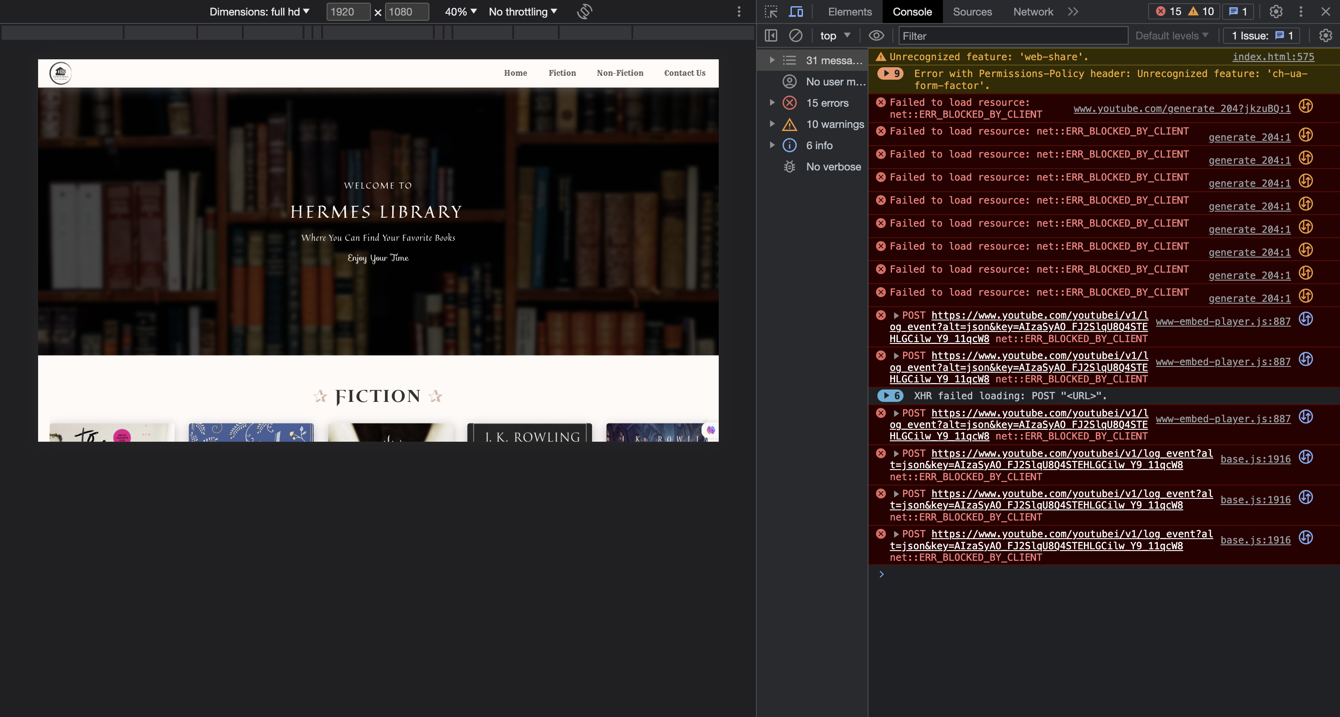

Figure 1. Error message inside Homepage

# Conclusion

In conclusion, this project is about developing a read only website with the subject relevant to the Book E-commerce System. The website is developed to let the book lovers throughout the world be able to find and trade books globally. Despite having contact form, because there is not server to send the form to, this website is still considered to be a read only website. The website is built to improve the coders’ frontend styling skills, especially for HTML and CSS skills. With 4 main types of pages, including Homepage, Category, Book Detail and Contact, and 4 other minor pages, including About Us, Privacy, Terms, and Copyrights page, this project is developed with 4-week timeline. One week for researching, one week for designing, and two weeks for implementing. The main resources used in this project are only HTML, and CSS so that the coders can concentrate on frontend. After this project, I learned how to use HTML tags correctly, and how to control flexbox, grid, and animation to improve the user interface design and the user experience when using the website.

Because this website has only frontend side, therefore, in future, I intend to add backend server to this website. All books and categories will be generated automatically using JavaScript. The users can also upload books for selling and adding to cart for buying action.

# Reference

[1]M. Nediger, “How to pick colors to captivate readers and communicate effectively,” *Venngage*, 19-Jan-2023. [Online]. Available: https://venngage.com/blog/how-to-pick-colors/. [Accessed: 08-Aug-2023]

[2]*YouTube*. [Online]. Available: https://www.youtube.com/. [Accessed: 08-Aug-2023]

# Appendix

* Link for online deploy: <https://puppychan.github.io/HermesLibrary/>
* Link for GitHub repository: <https://github.com/Puppychan/HermesLibrary>
* Link for online demonstration: [WebProgramming_ASM1.mov](https://rmiteduau-my.sharepoint.com/:v:/g/personal/s3879954_rmit_edu_vn/EQZ_-AIR8GFBiInOjKqlQd8BY1UY6677Jt30enxLskAV9g?e=vJAWfr)

## Appendix 1



Appendix 1 1. Homepage - Desktop design - 1

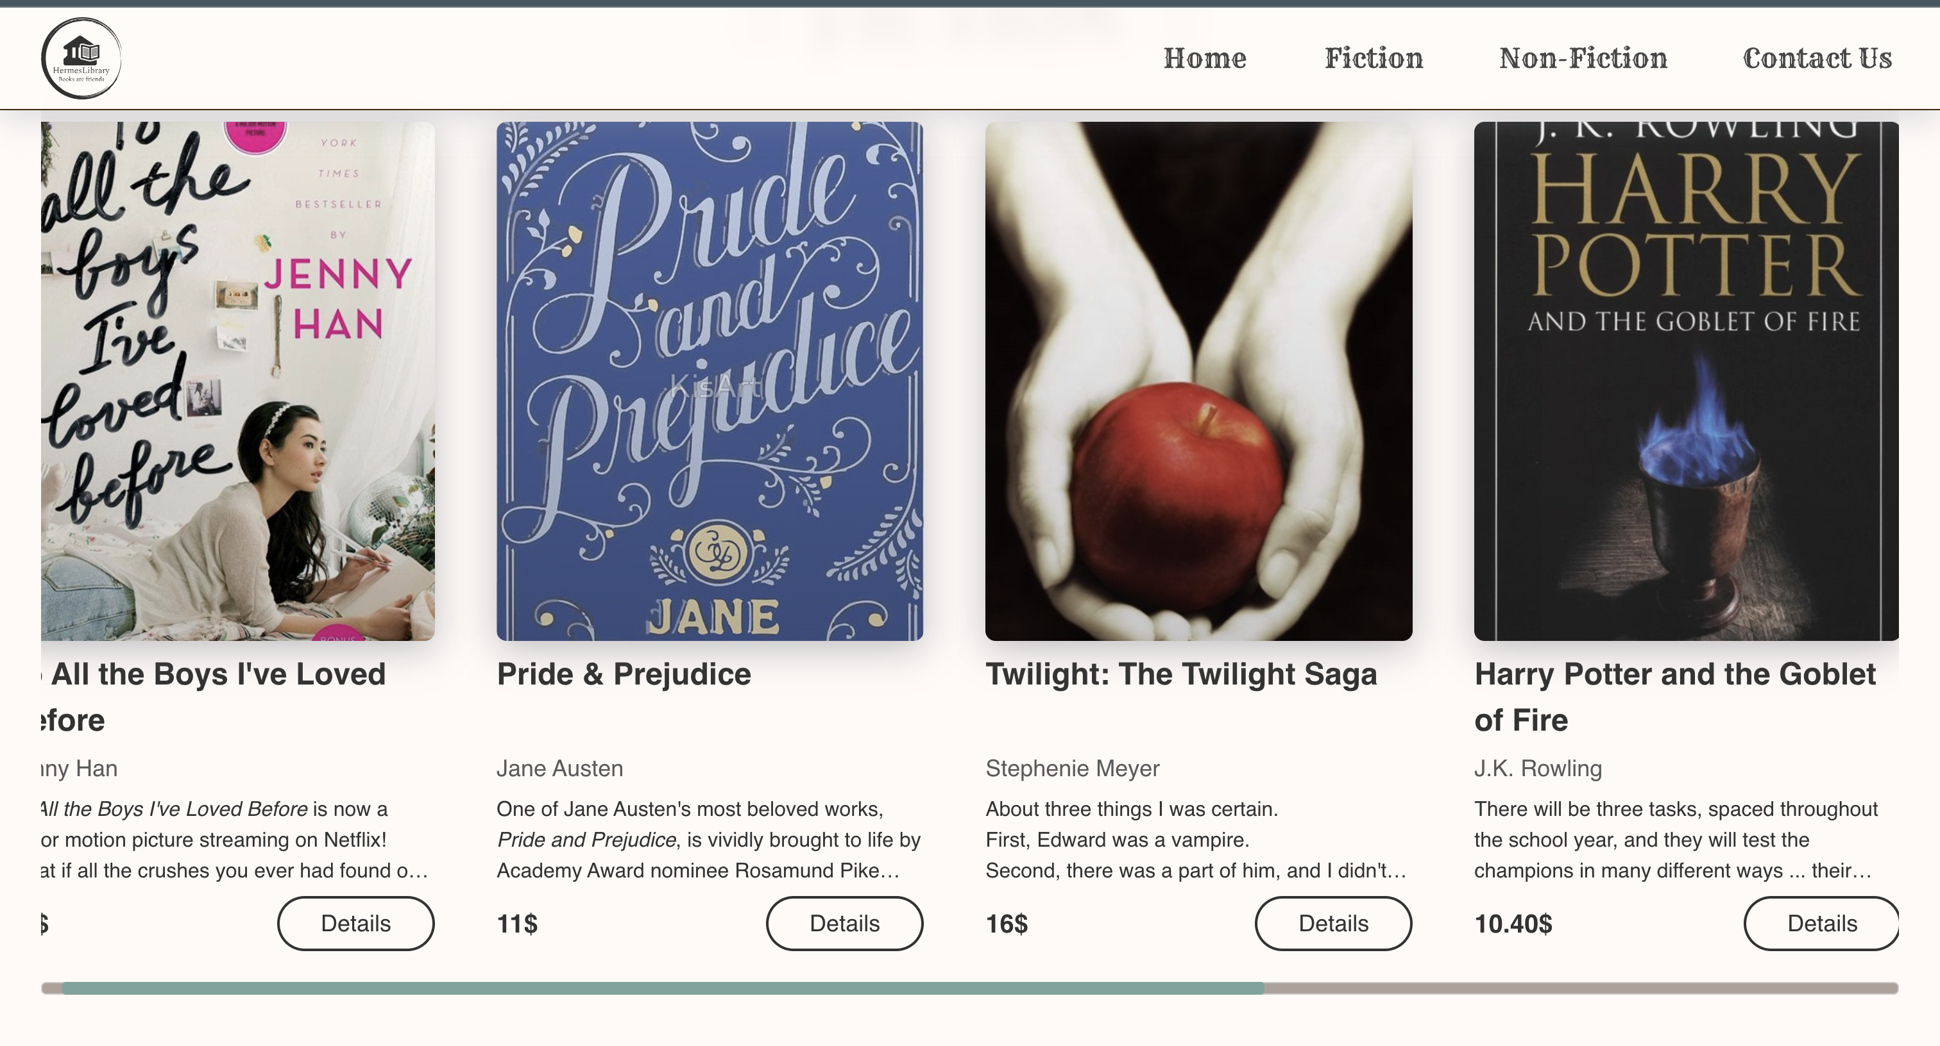

Appendix 1 2. Homepage - Desktop design - 2

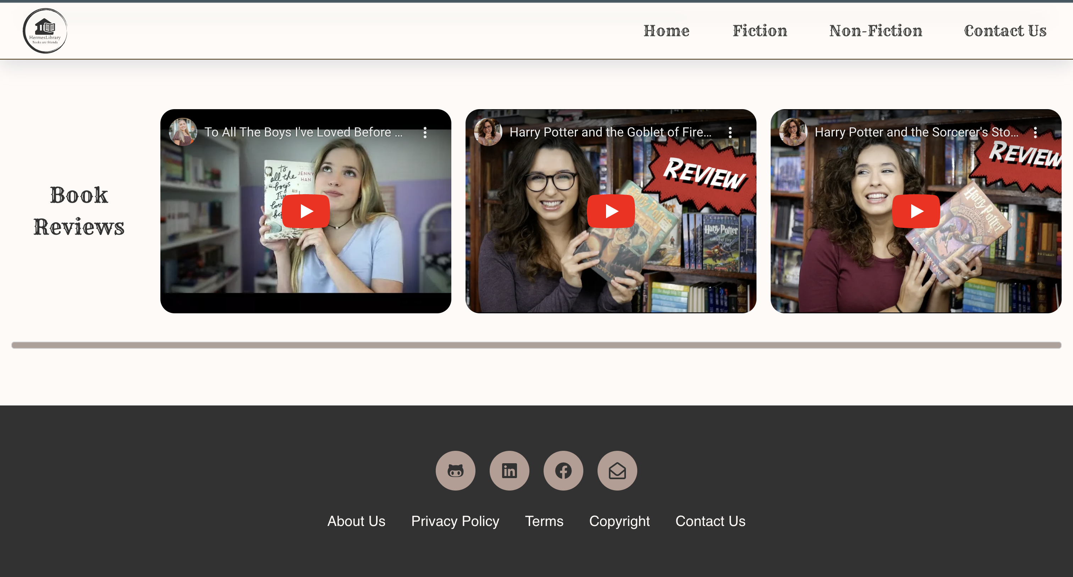

Appendix 1 3. Homepage - Desktop design – 3

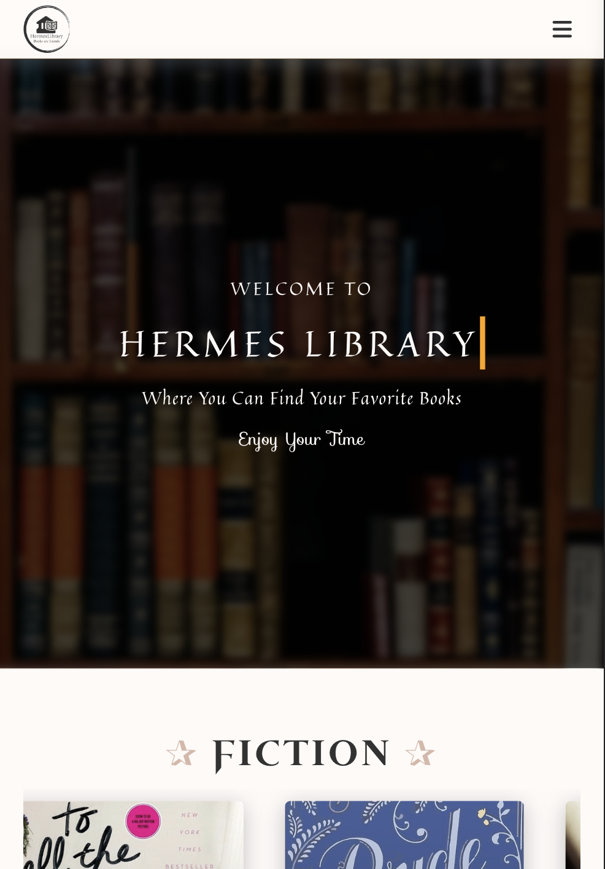

Appendix 1 4. Homepage – iPad Air design – 1

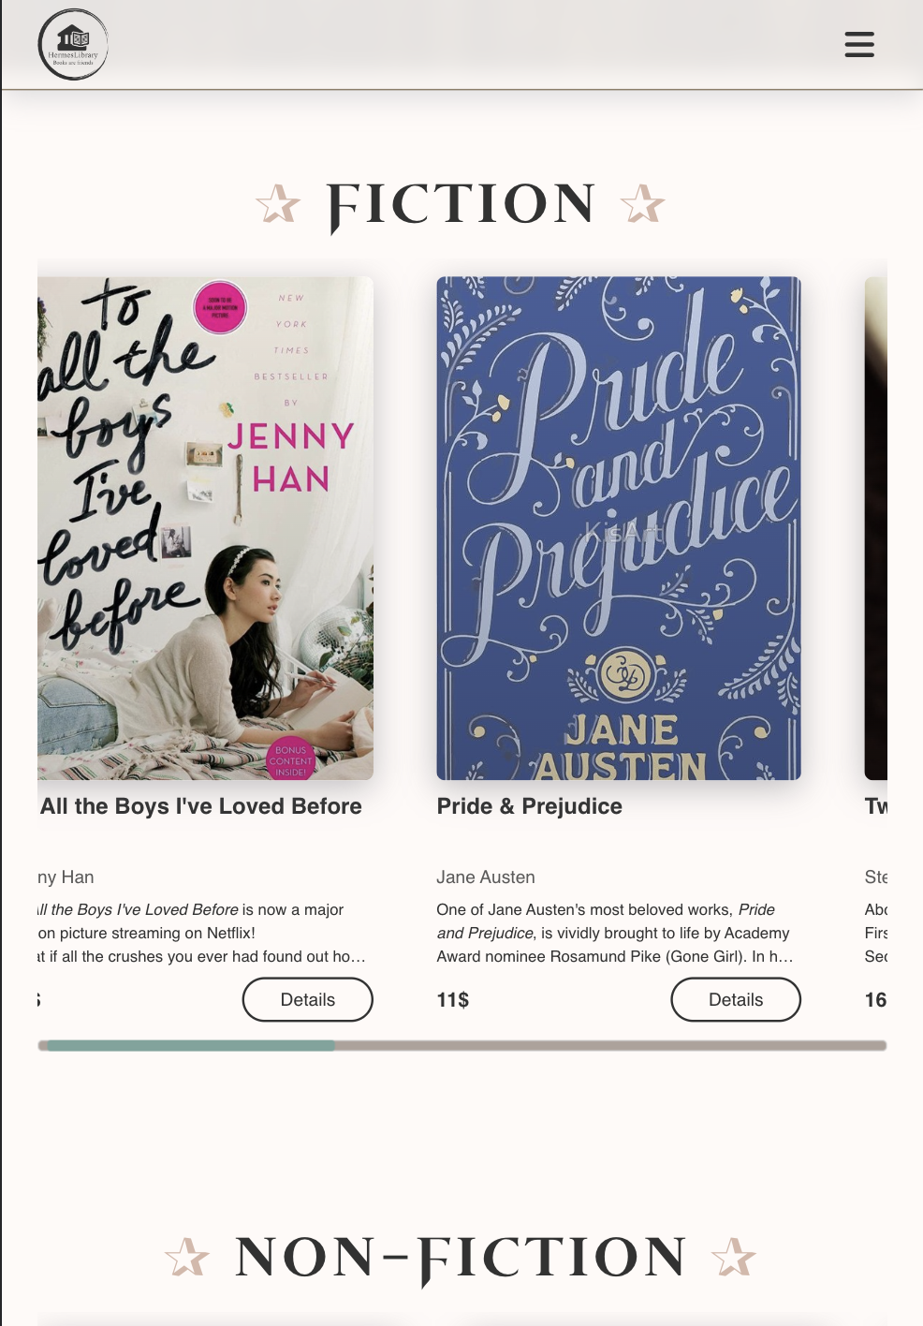

Appendix 1 5. Homepage – iPad Air design – 2

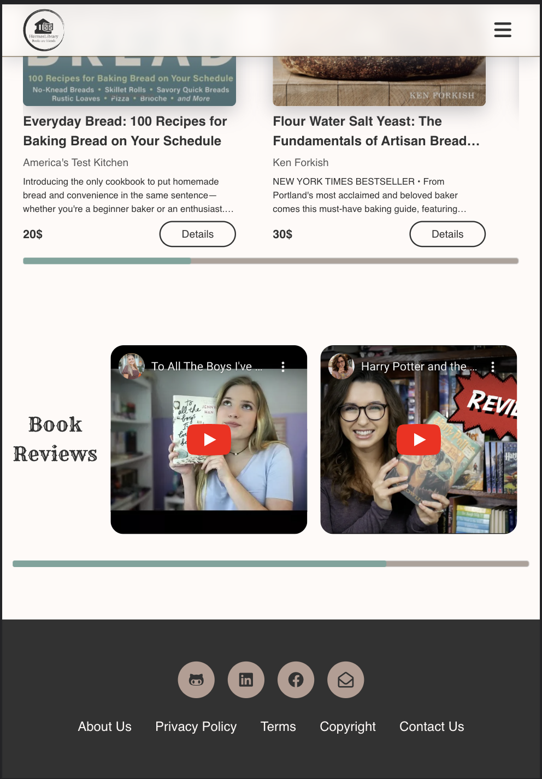

Appendix 1 6. Homepage – iPad Air design – 3



Appendix 1 7. Homepage – iPhone 12 Pro design – 1



Appendix 1 8. Homepage – iPhone 12 Pro design – 2

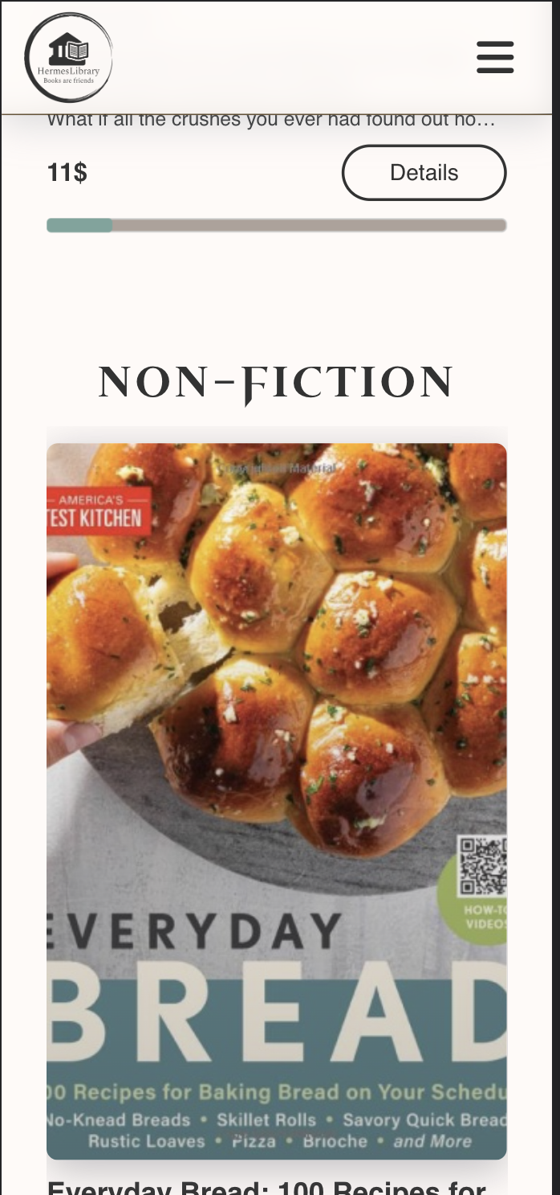

Appendix 1 9. Homepage – iPhone 12 Pro design – 3

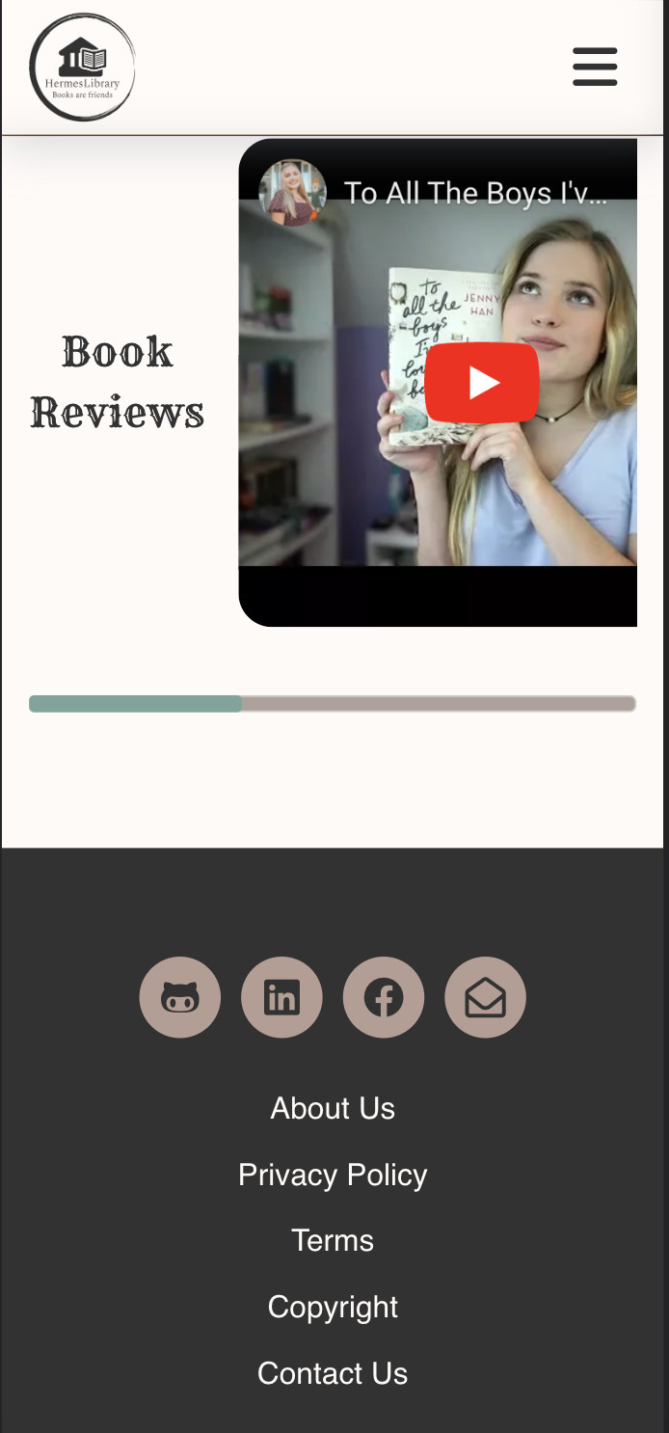

Appendix 1 10. Homepage – iPhone 12 Pro design – 4

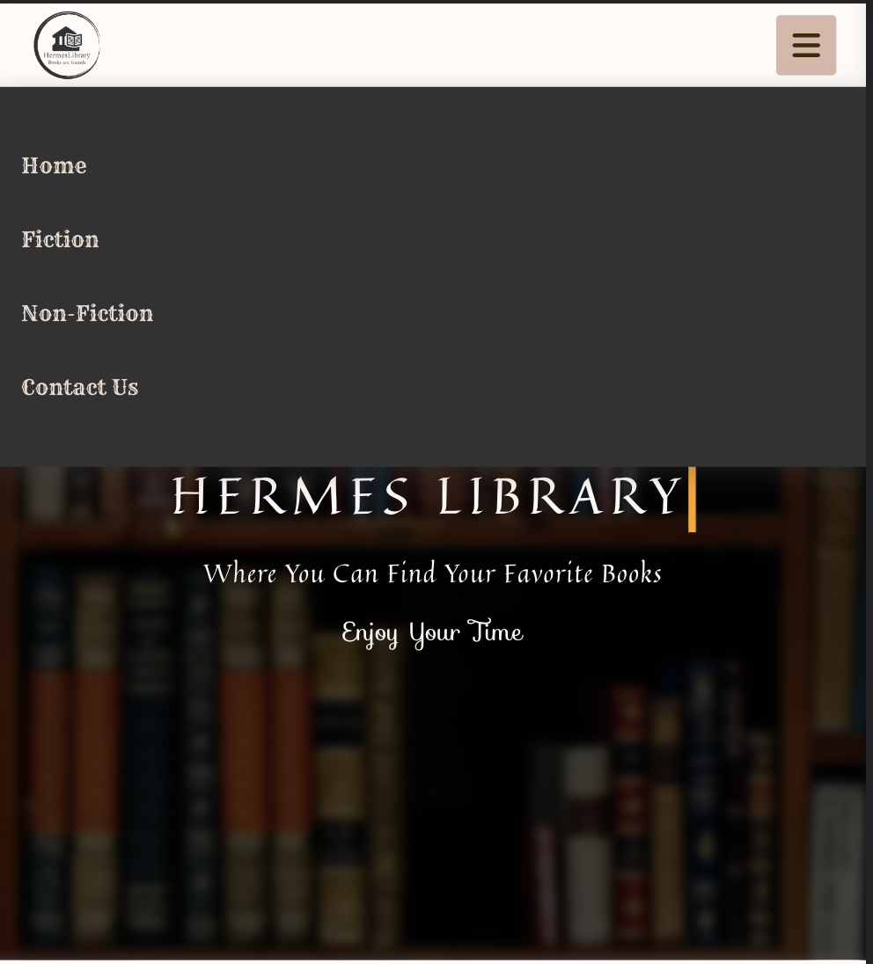

Appendix 1 11. Homepage – iPad Air design – Navigation Bar

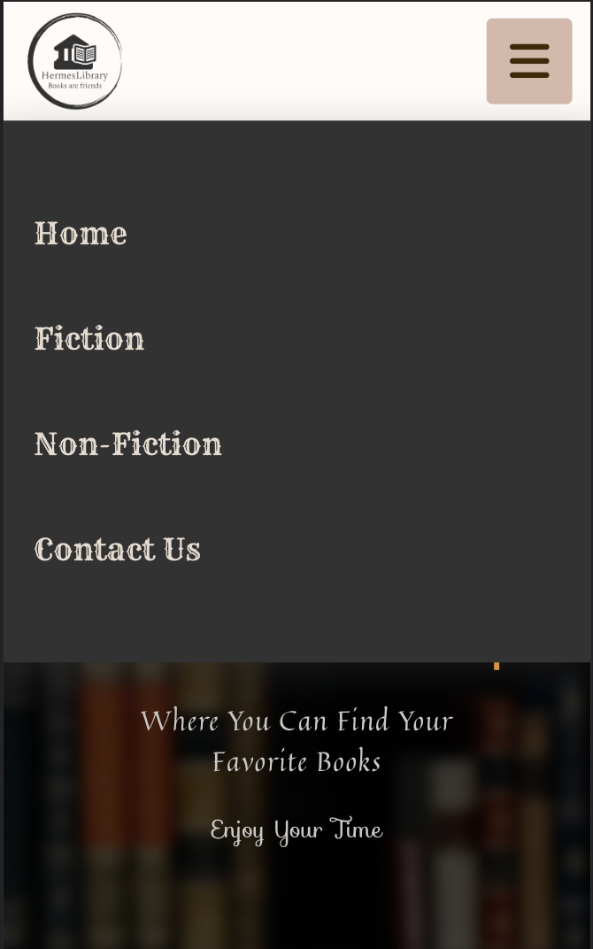

Appendix 1 12. Homepage – iPhone Pro 12 design – Navigation Bar

## Appendix 2



Appendix 2 1 Category page - Desktop - 1

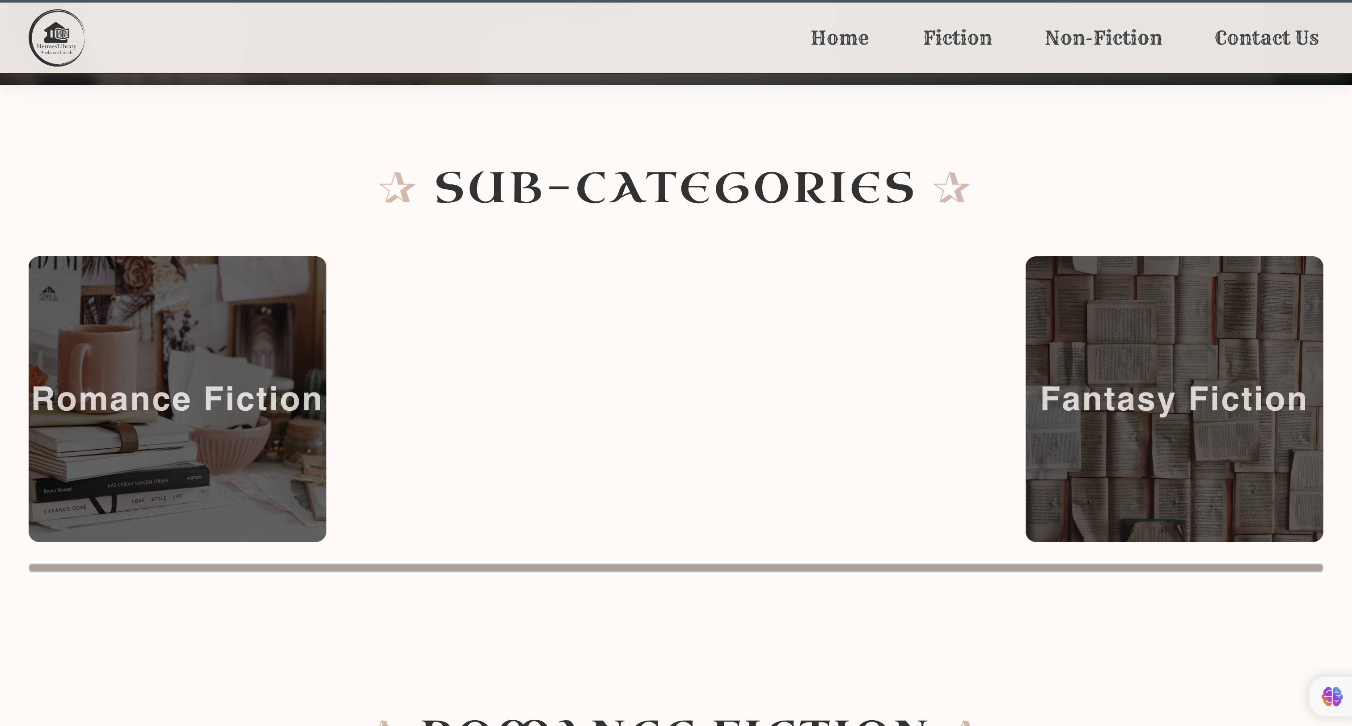

Appendix 2 2 Category page - Desktop - 2

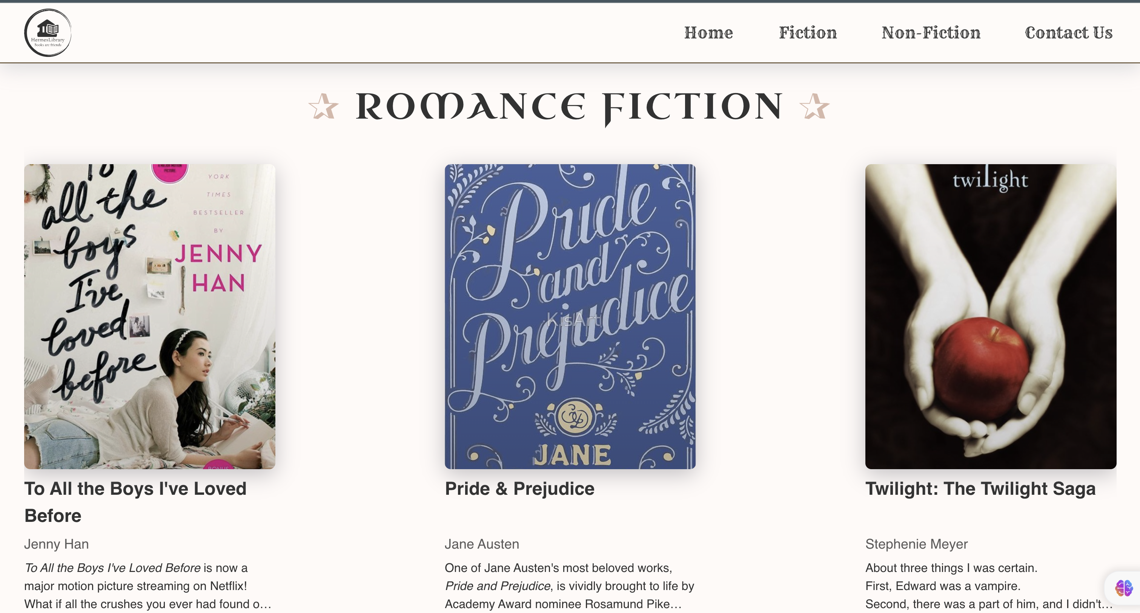

Appendix 2 3 Category page - Desktop - 3

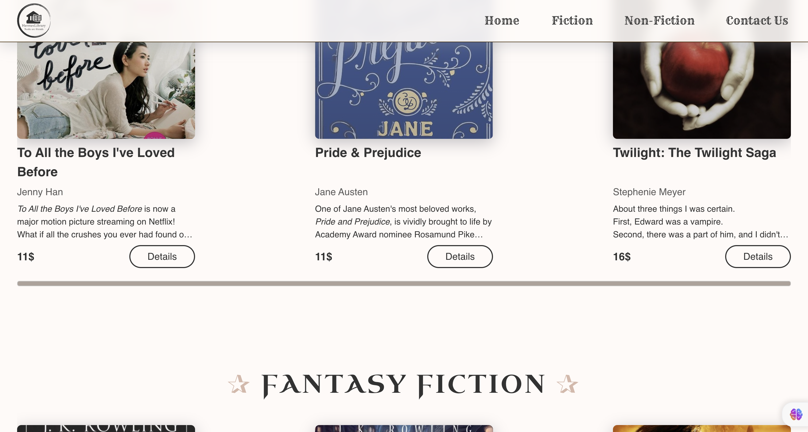

Appendix 2 4 Category page - Desktop - 4

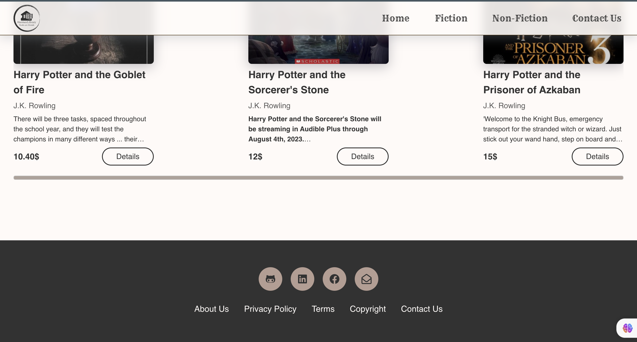

Appendix 2 5 Category page - Desktop – 5

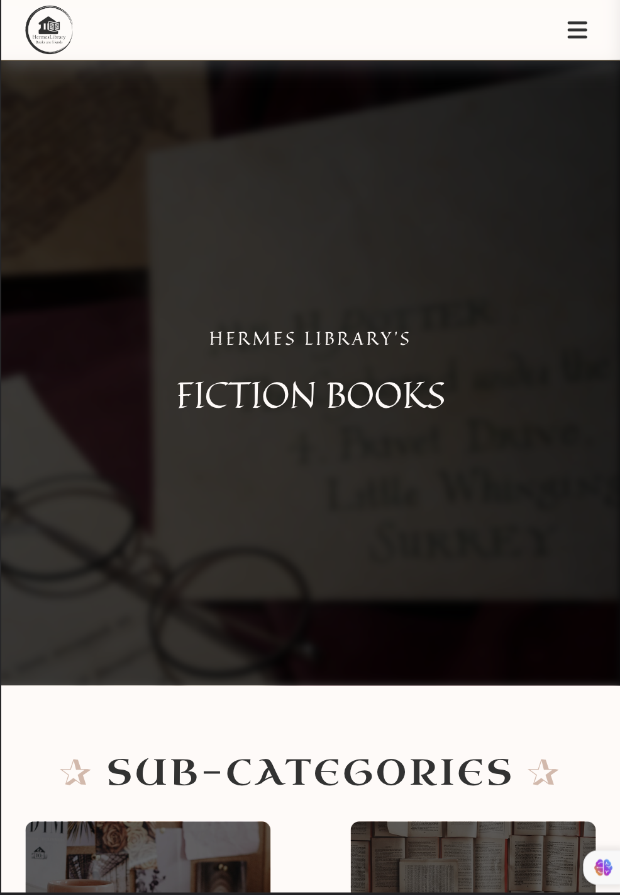

Appendix 2 6 Category page – iPad Air – 1

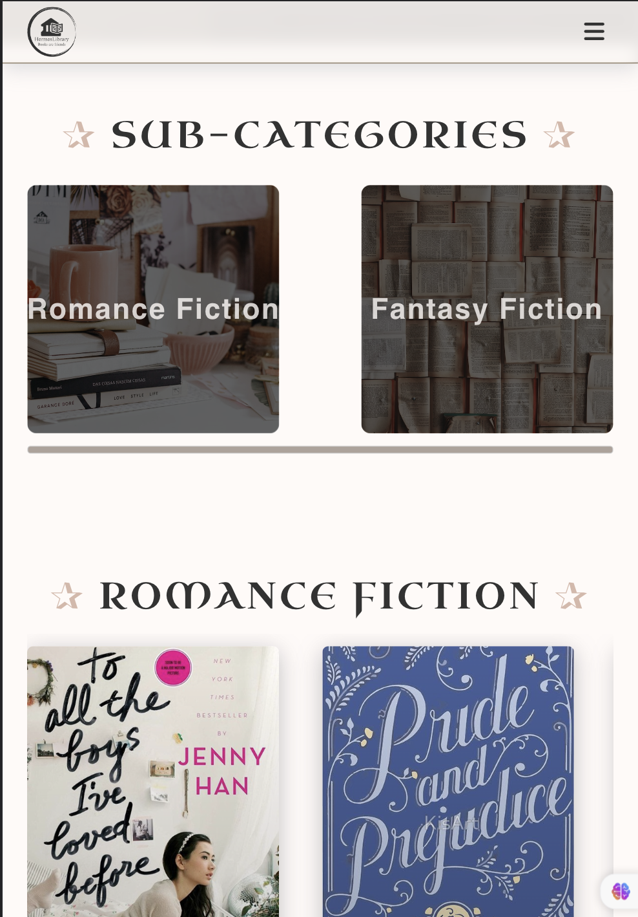

Appendix 2 7 Category page – iPad Air – 2

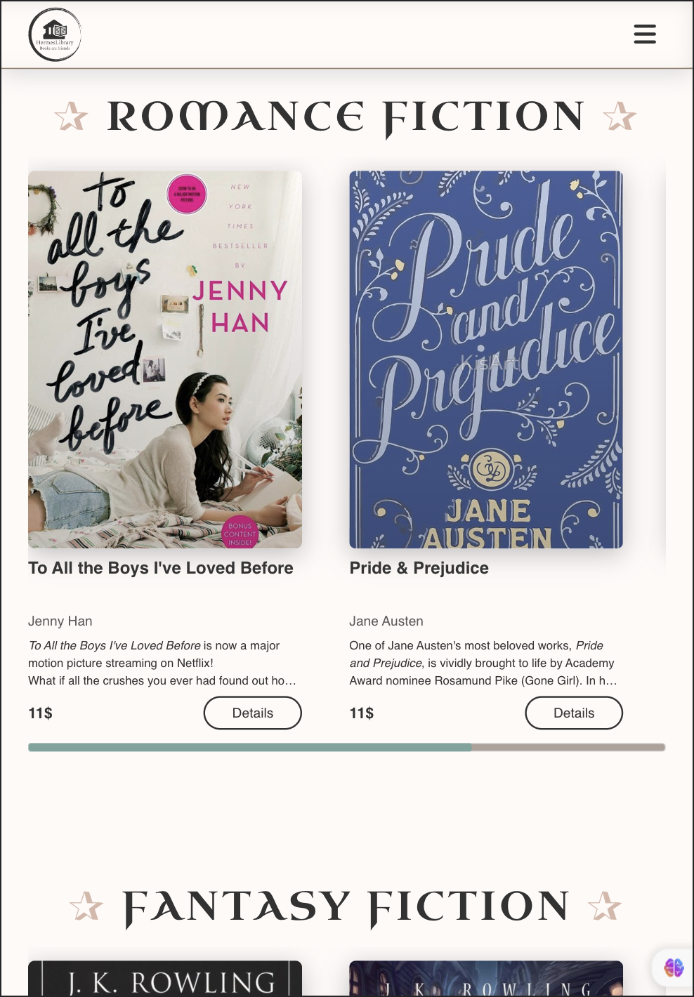

Appendix 2 8 Category page – iPad Air – 3

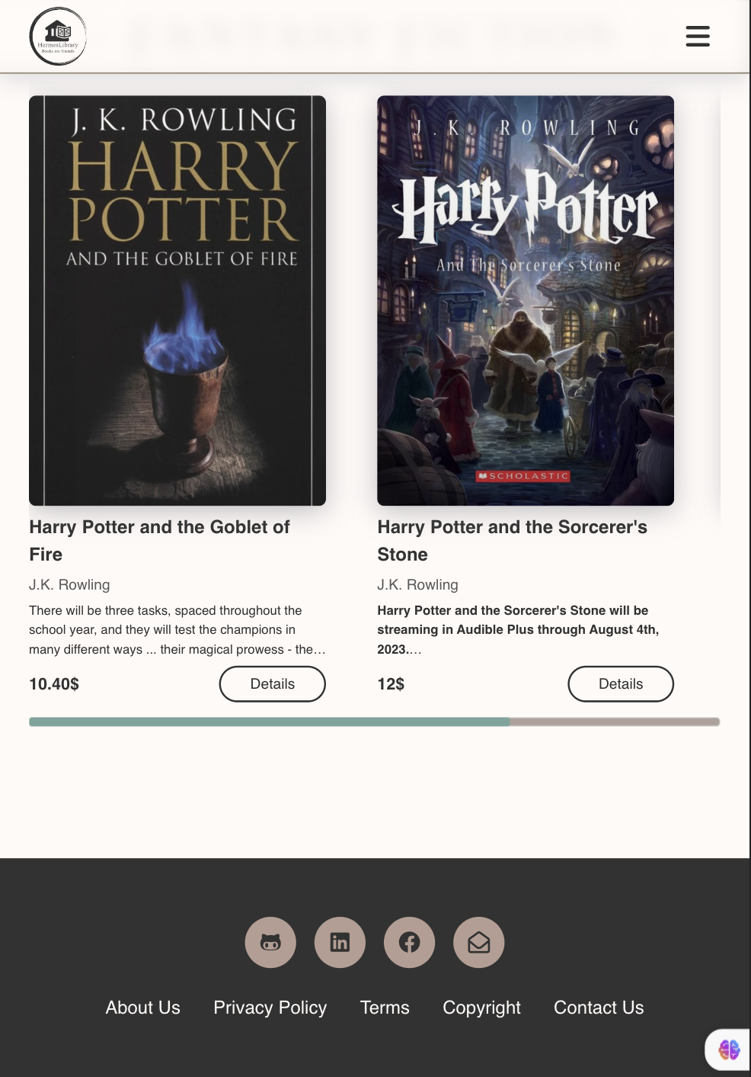

Appendix 2 9 Category page – iPad Air – 4



Appendix 2 10 Category page – iPhone 12 Pro – 1

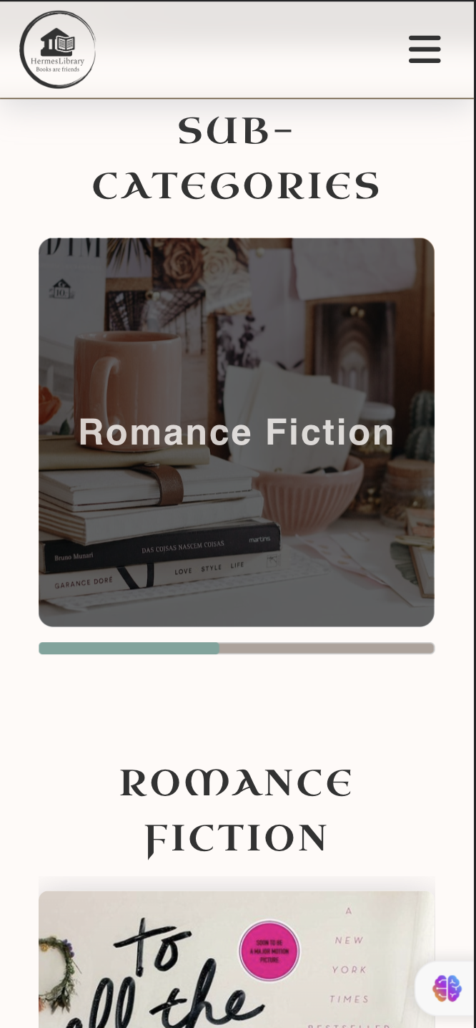

Appendix 2 11 Category page – iPhone 12 Pro – 2



Appendix 2 12 Category page – iPhone 12 Pro – 3

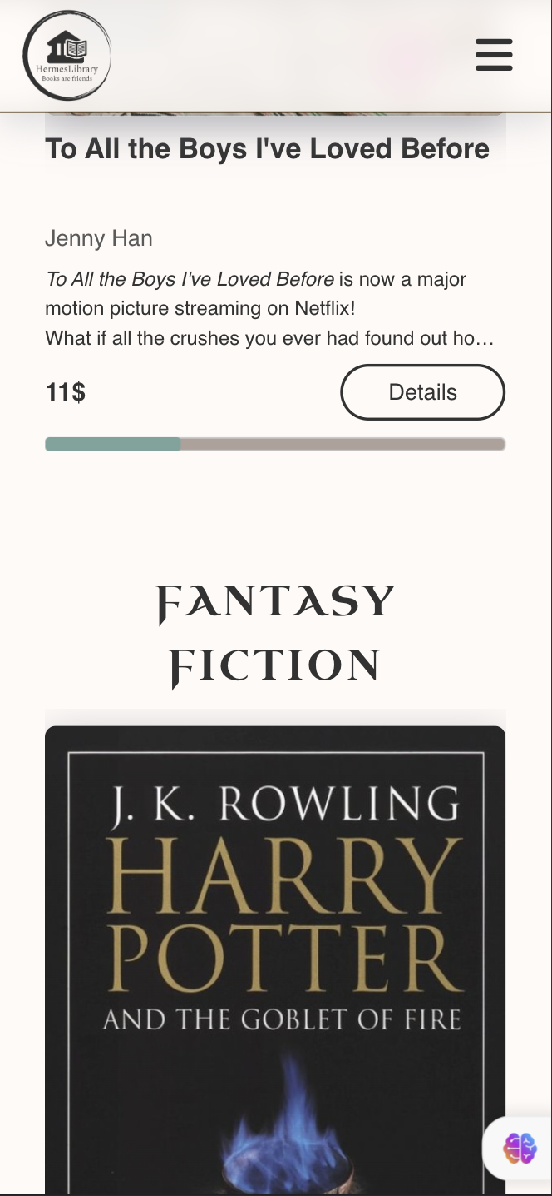

Appendix 2 13 Category page – iPhone 12 Pro – 4

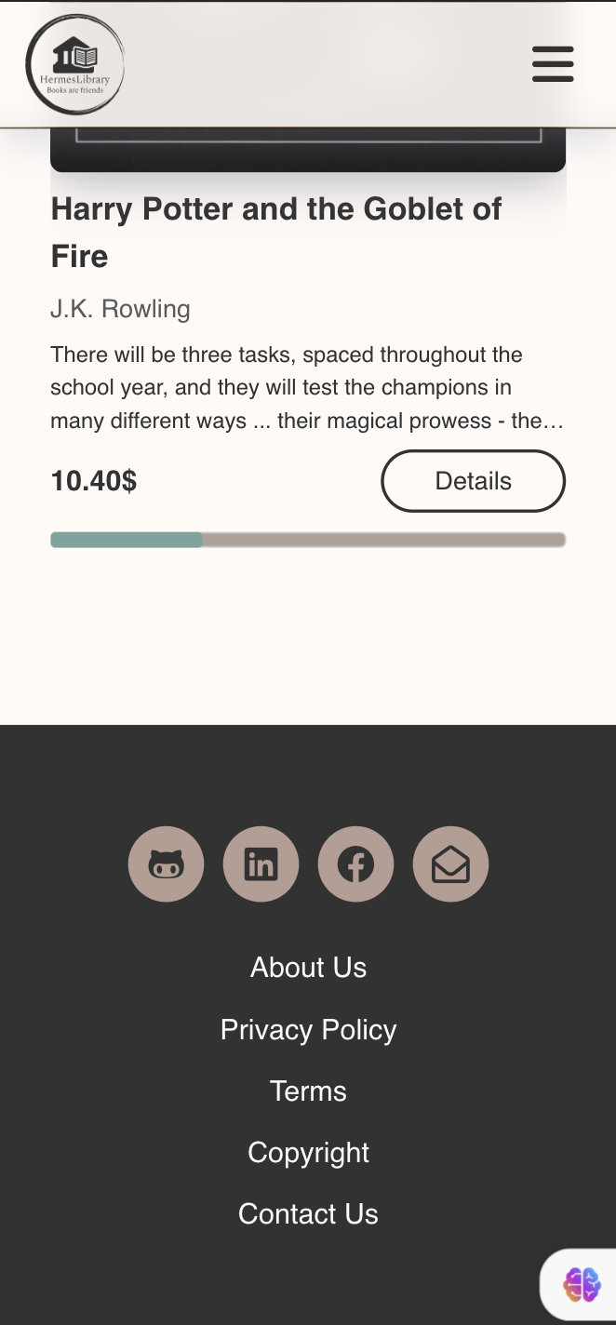

Appendix 2 14 Category page – iPhone 12 Pro – 5

## Appendix 3

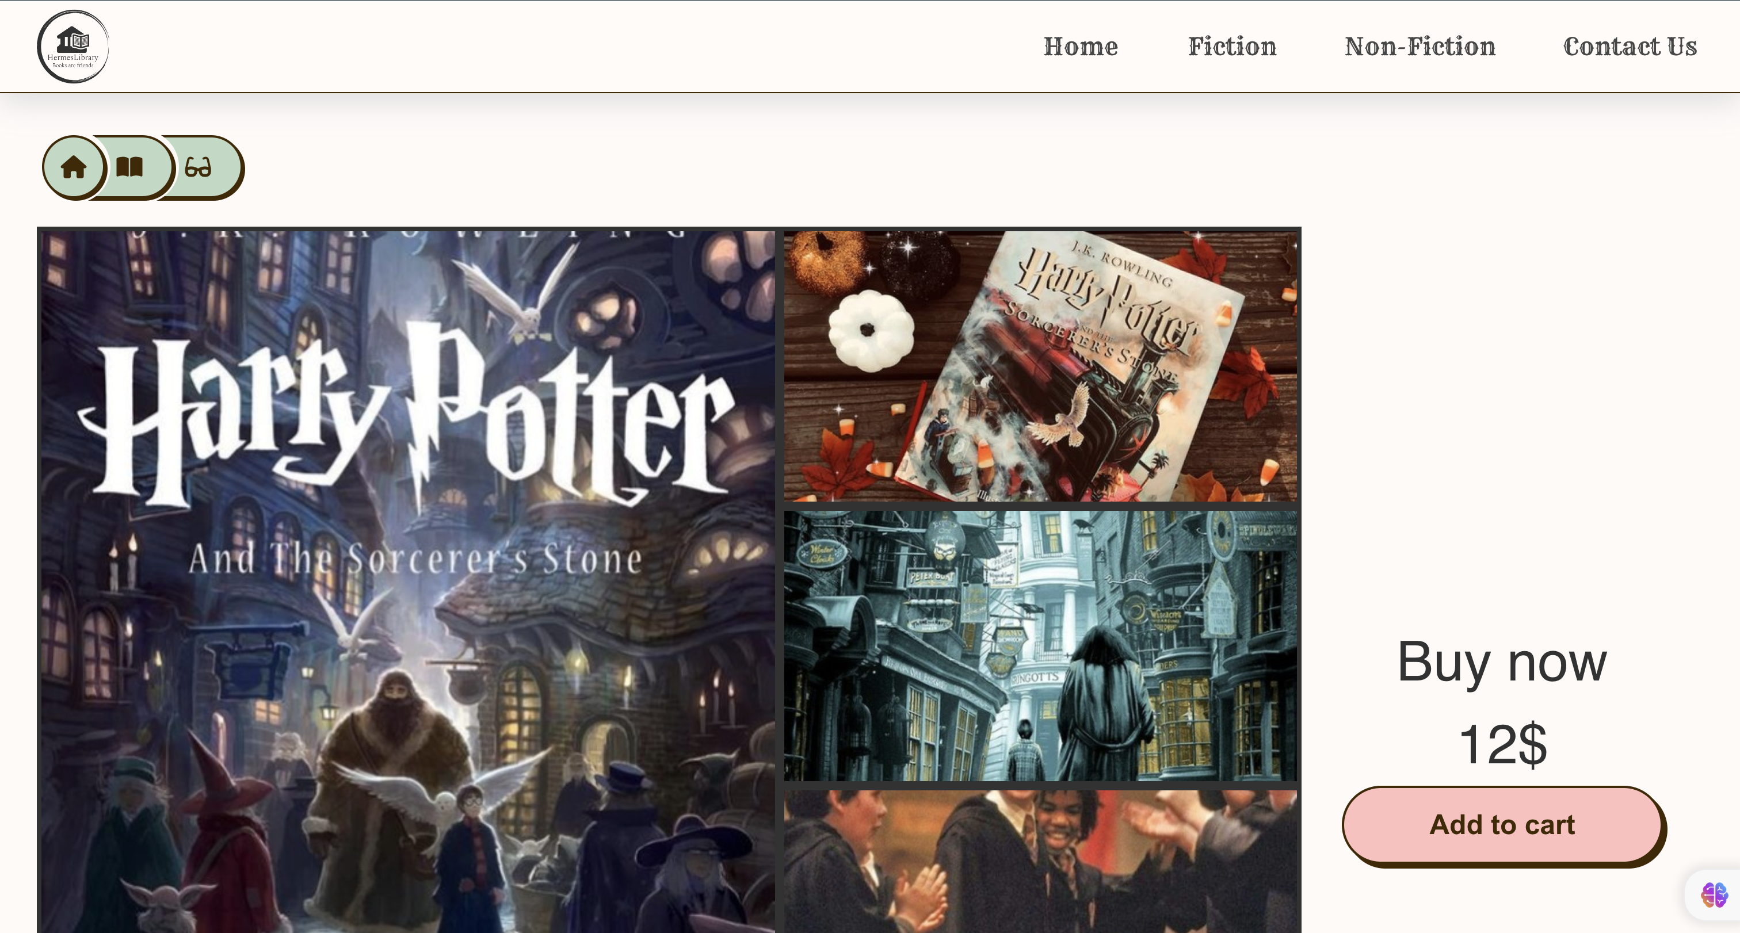

Appendix 3 1 Book Detail page - Desktop - 1

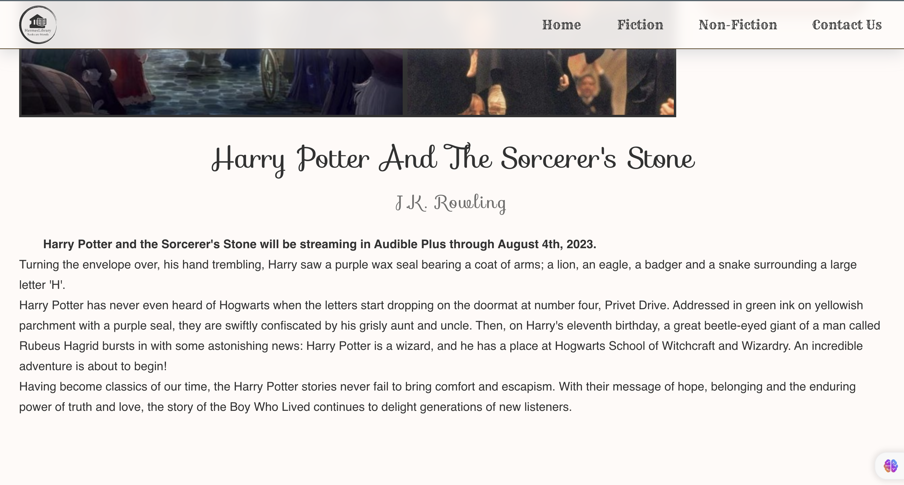

Appendix 3 2 Book Detail page - Desktop - 2

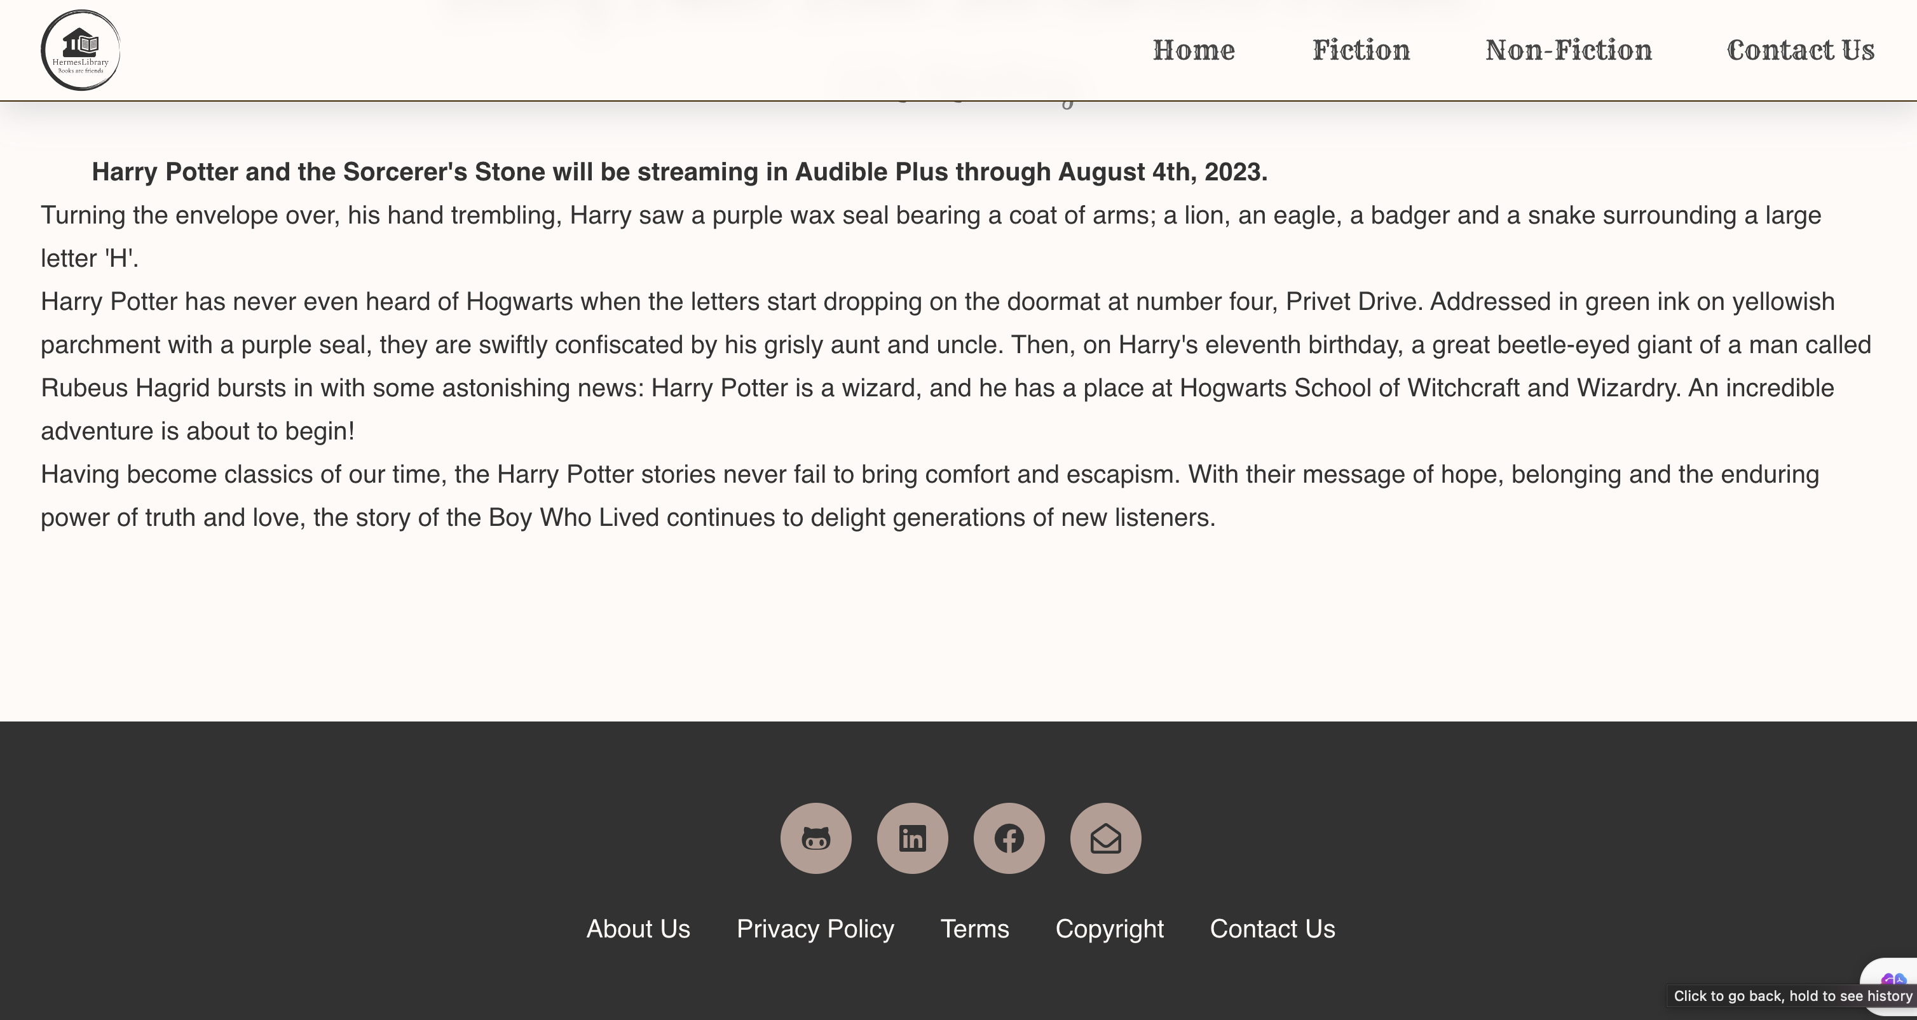

Appendix 3 3 Book Detail page - Desktop - 3

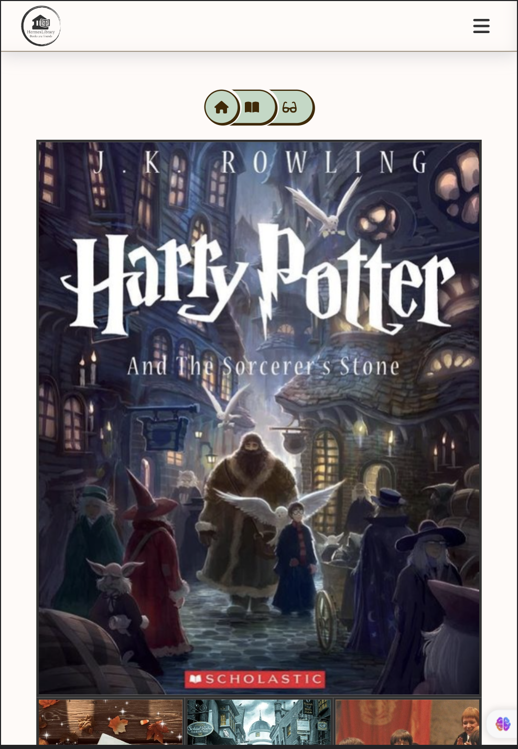

Appendix 3 4 Book Detail page – iPad Air- 1

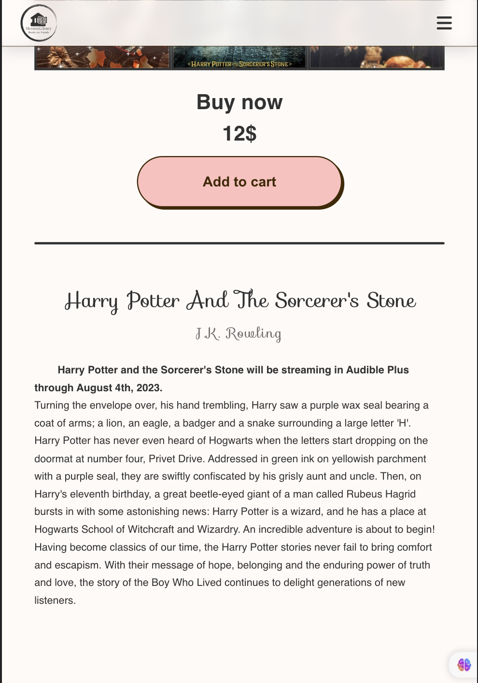

Appendix 3 5 Book Detail page – iPad Air- 2

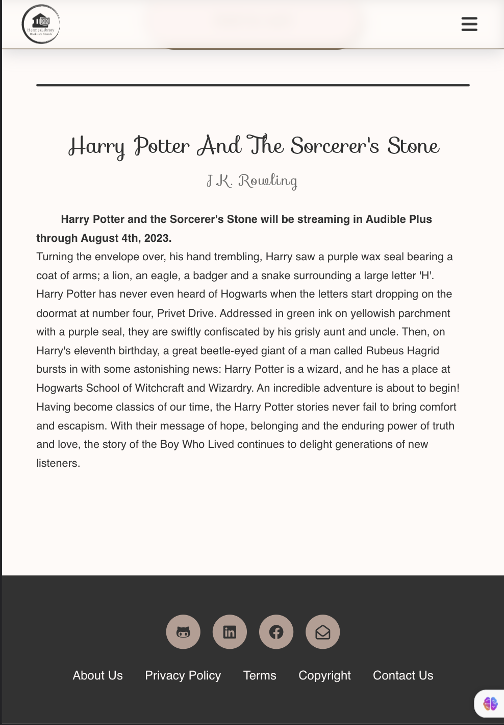

Appendix 3 6 Book Detail page – iPad Air - 3

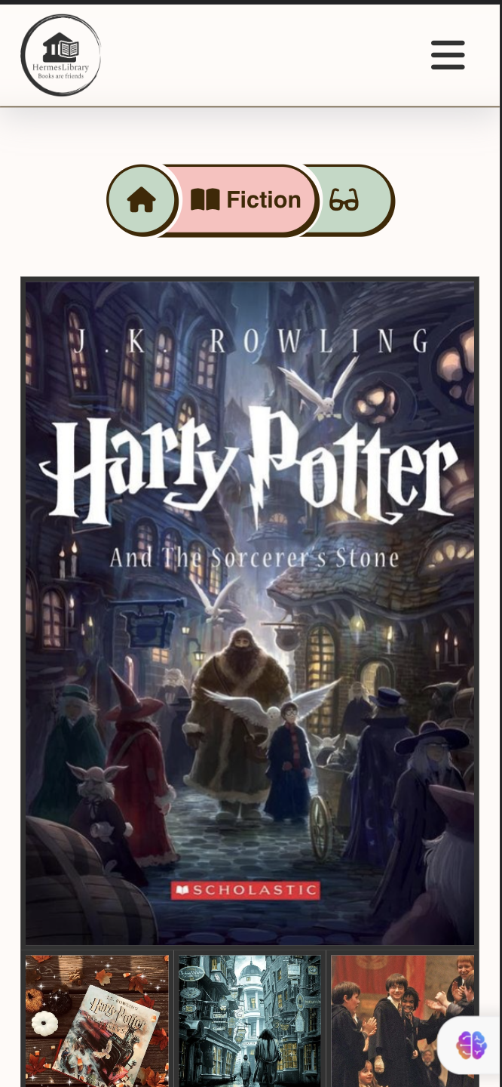

Appendix 3 7 Book Detail page – iPhone Pro 12 - 1

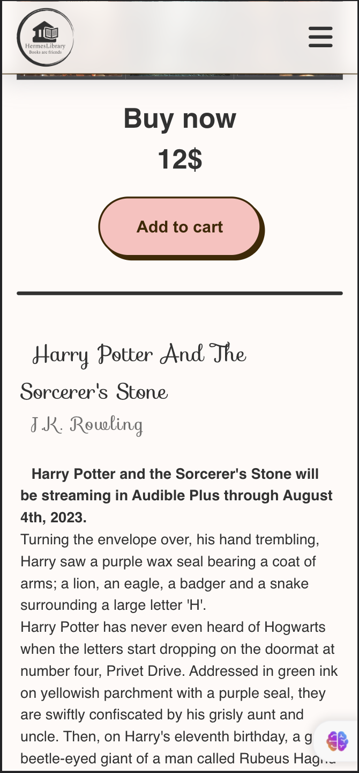

Appendix 3 8 Book Detail page – iPhone Pro 12 – 2

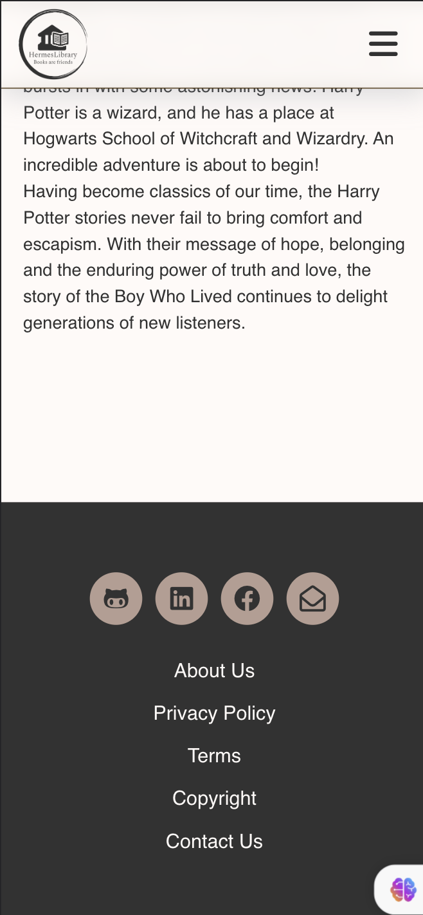

Appendix 3 9 Book Detail page – iPhone Pro 12 - 3

## Appendix 4

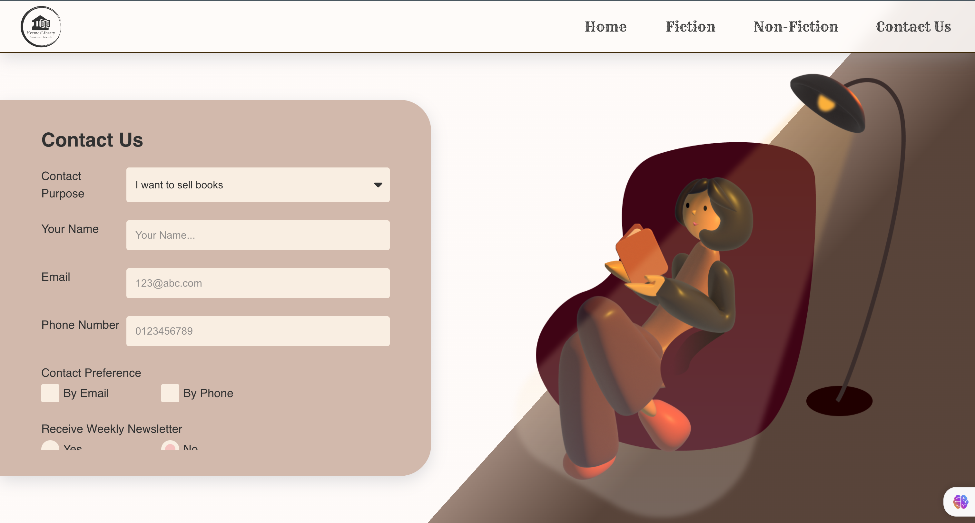

Appendix 4 1 Contact page - Desktop -1

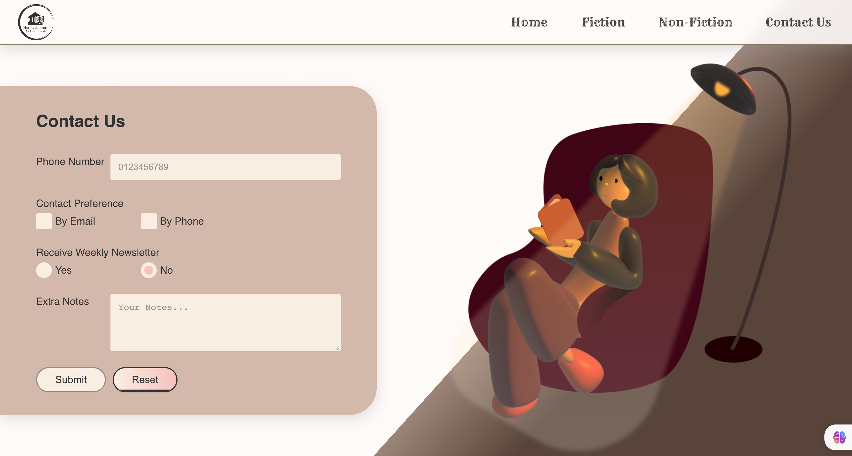

Appendix 4 2 Contact page - Desktop -2

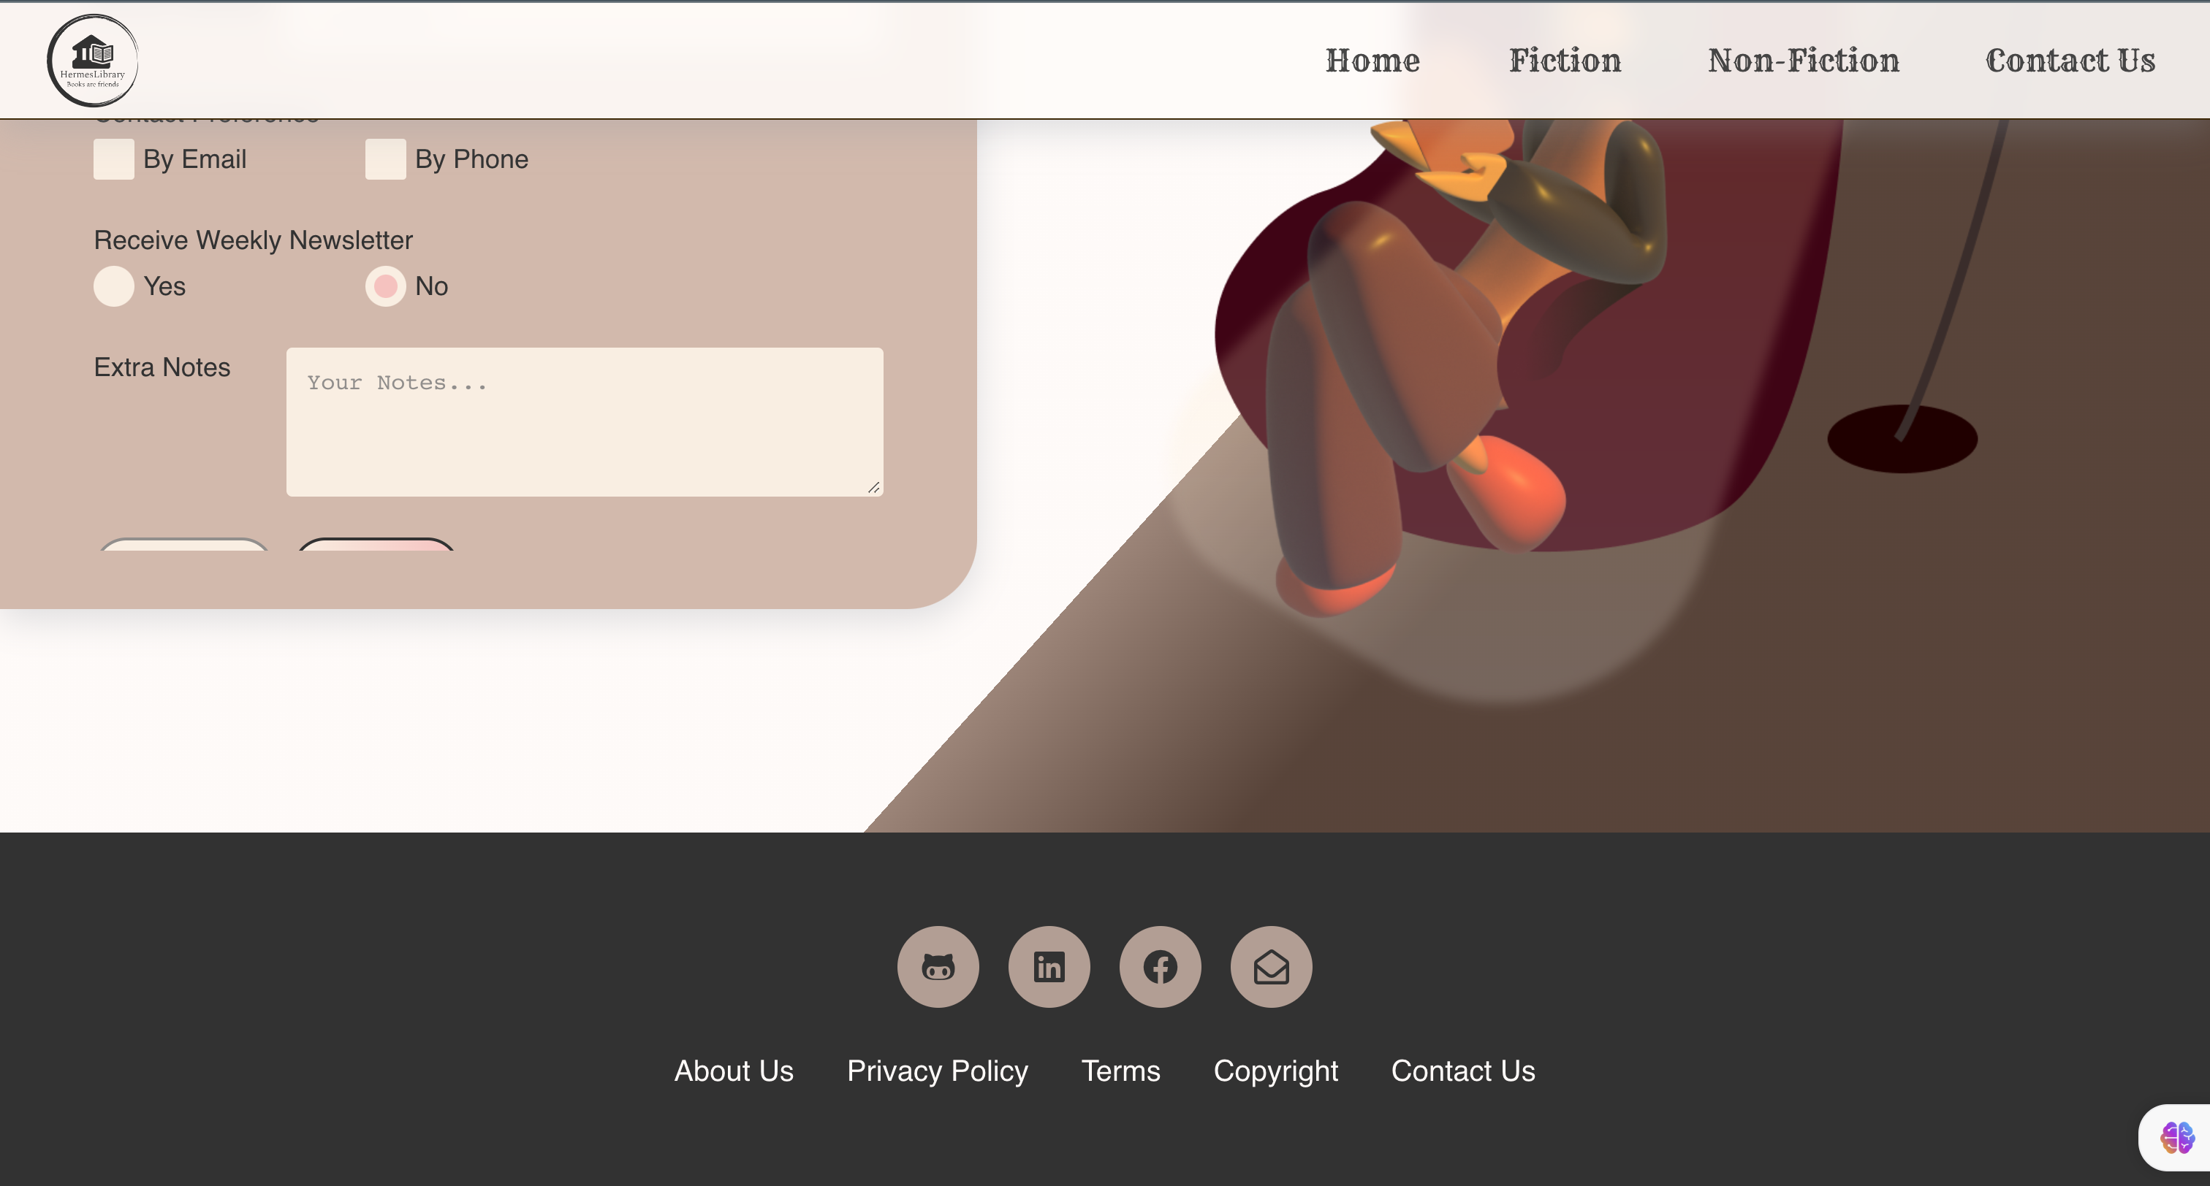

Appendix 4 3 Contact page - Desktop -3

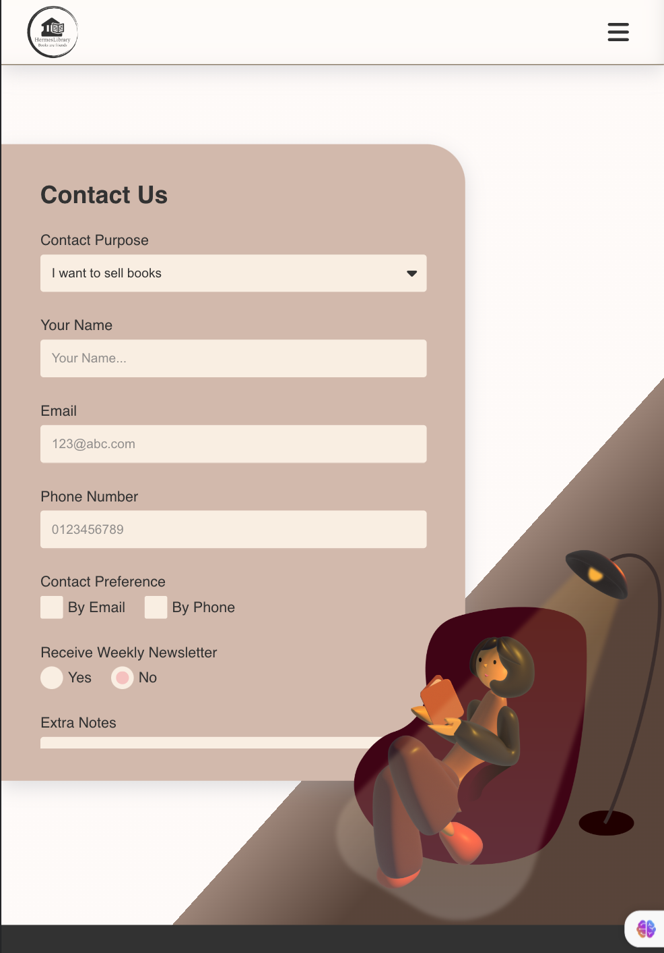

Appendix 4 4 Contact page – iPad Air -1

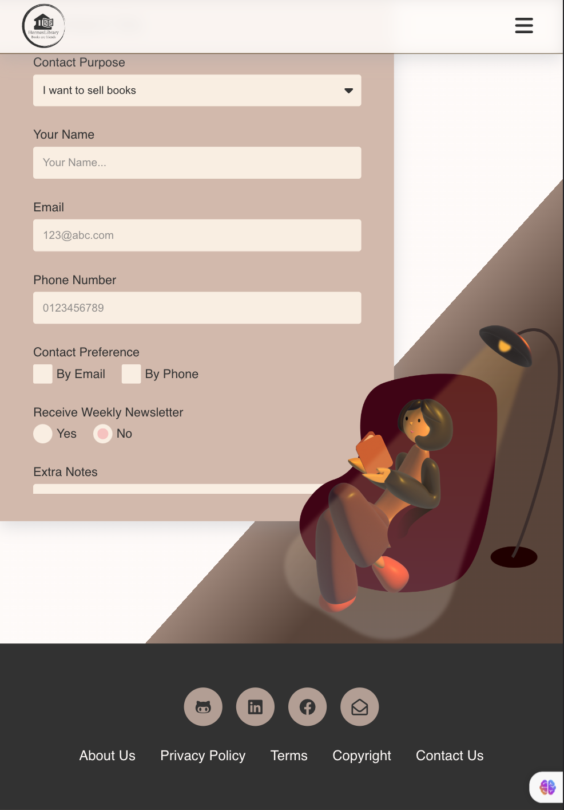

Appendix 4 5 Contact page – iPad Air -2

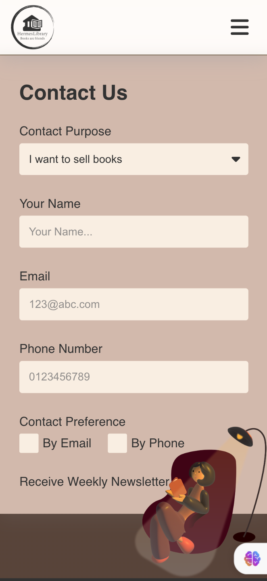

Appendix 4 6 Contact page – iPhone 12 Pro -1

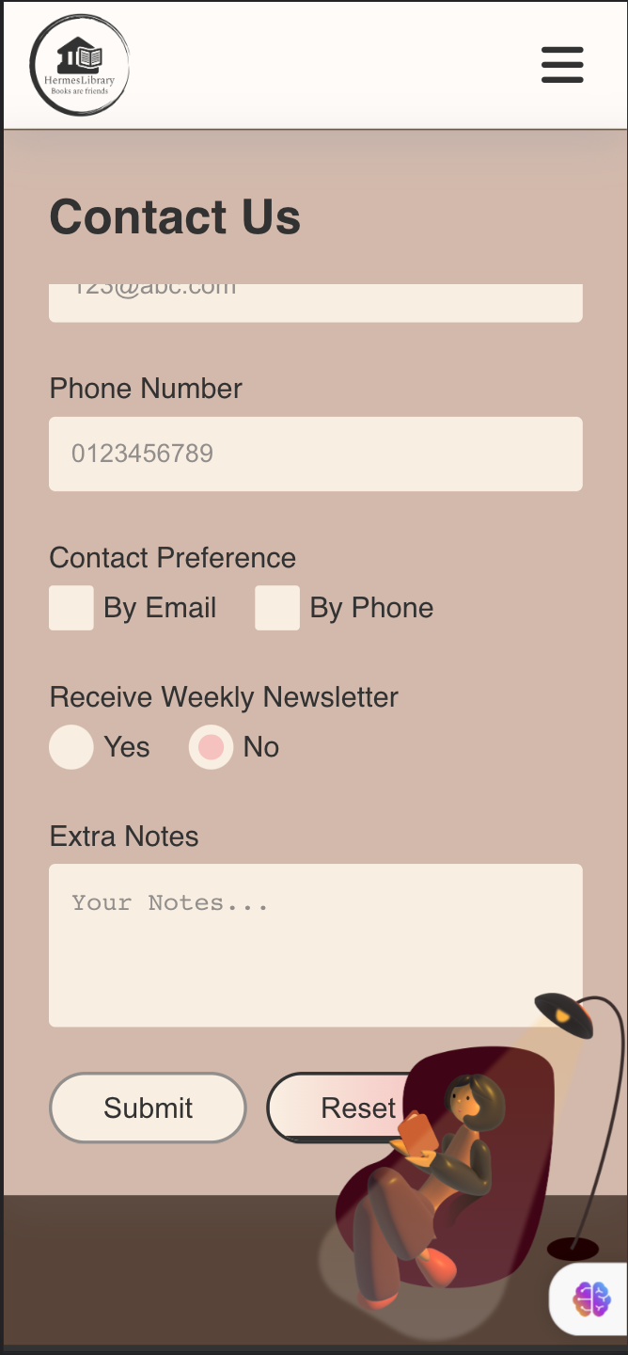

Appendix 4 7 Contact page – iPhone 12 Pro -2

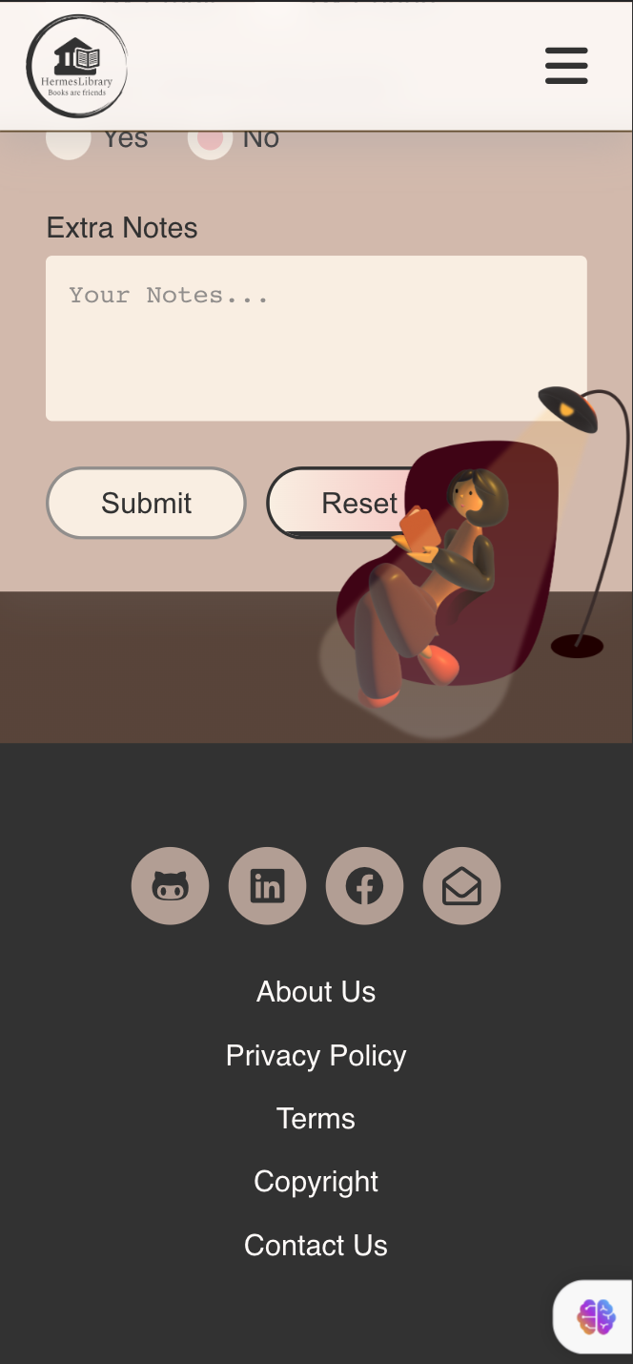

Appendix 4 8 Contact page – iPhone 12 Pro -3

## Appendix 5



Appendix 5 1 About Us Page - Desktop -1

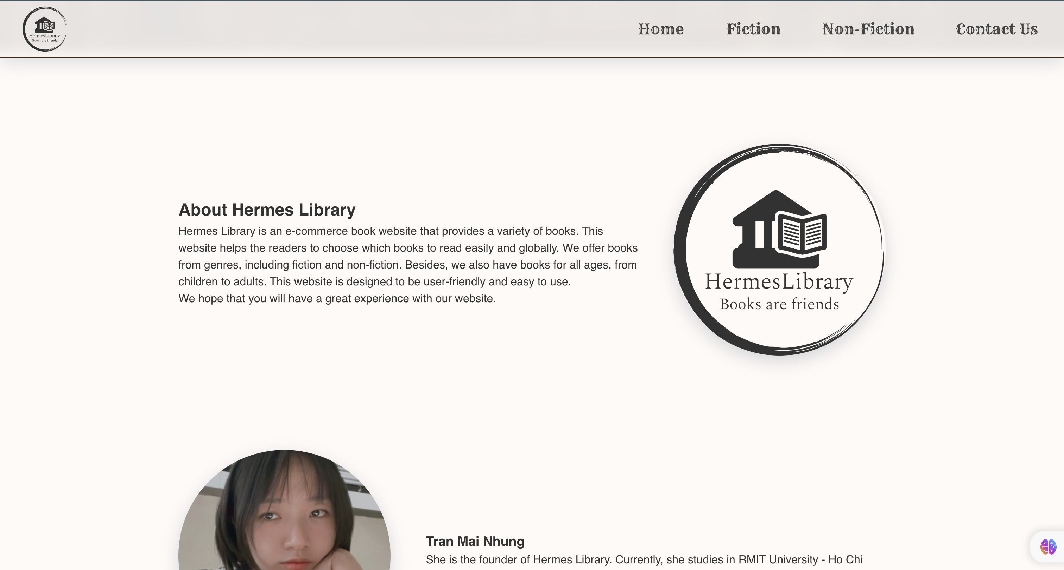

Appendix 5 2 About Us Page - Desktop -2

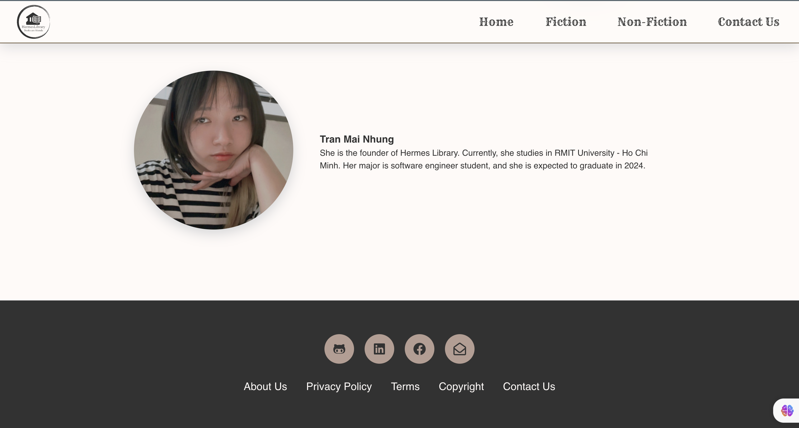

Appendix 5 3 About Us Page - Desktop -3

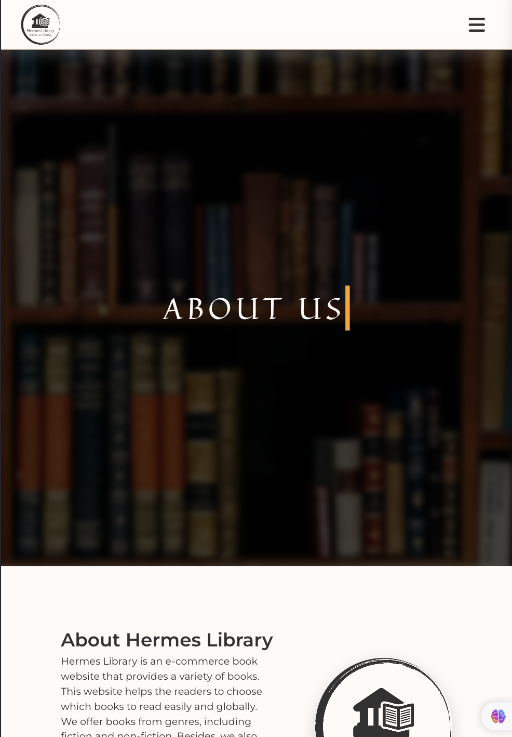

Appendix 5 4 About Us Page – iPad Air -1

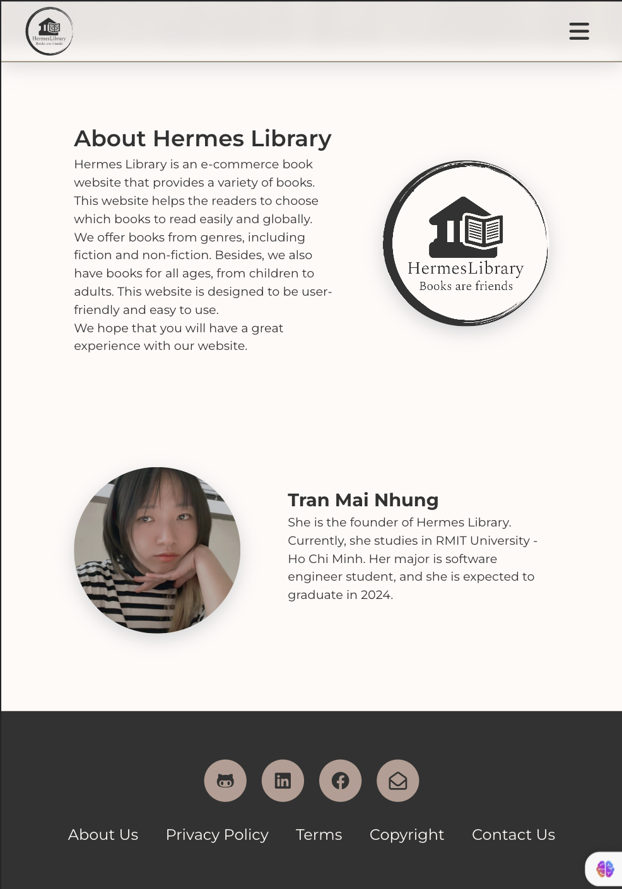

Appendix 5 5 About Us Page – iPad Air -2



Appendix 5 6 About Us Page – iPhone Pro 12 -1

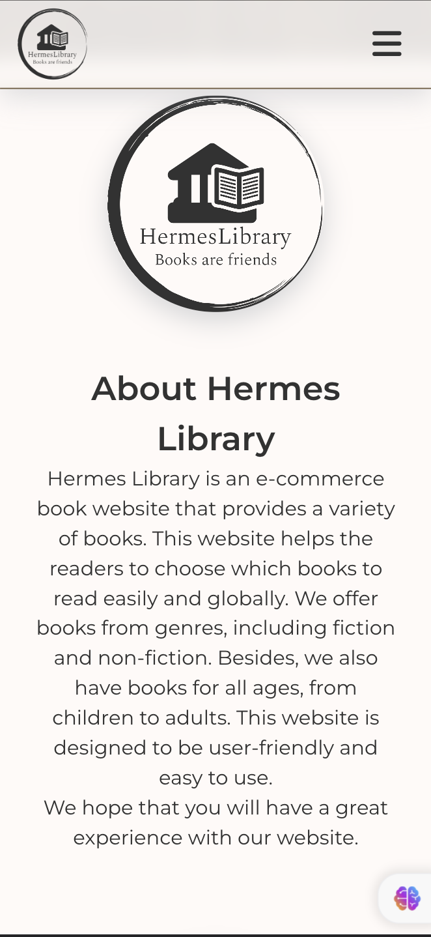

Appendix 5 7 About Us Page – iPhone Pro 12 -2

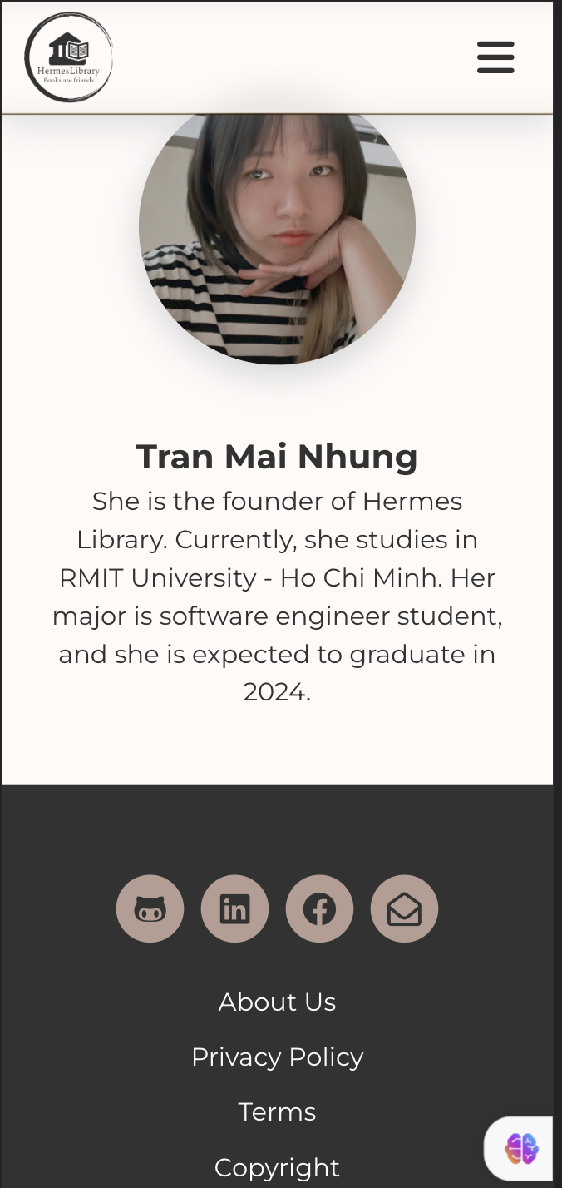

Appendix 5 8 About Us Page – iPhone Pro 12 -3

## Appendix 6

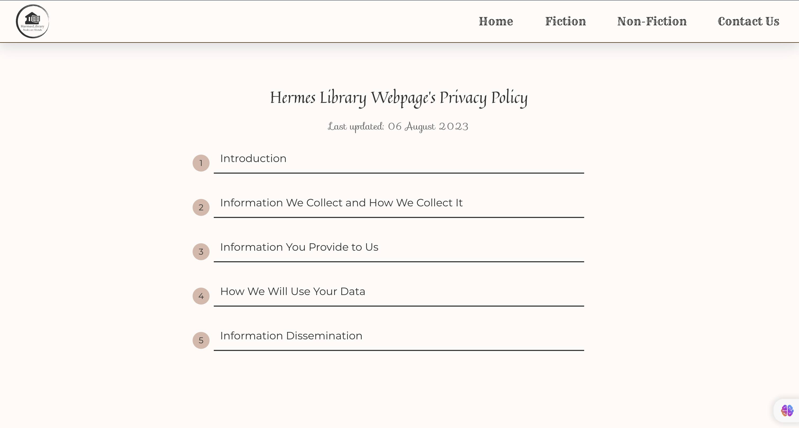

Appendix 6 1 Privacy Page - Desktop - 1

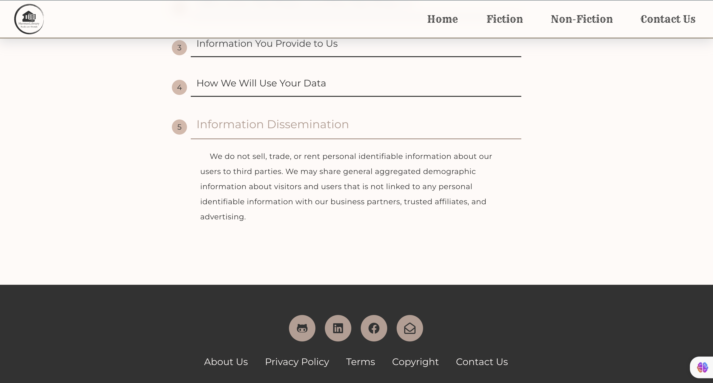

Appendix 6 2 Privacy Page - Desktop - 2

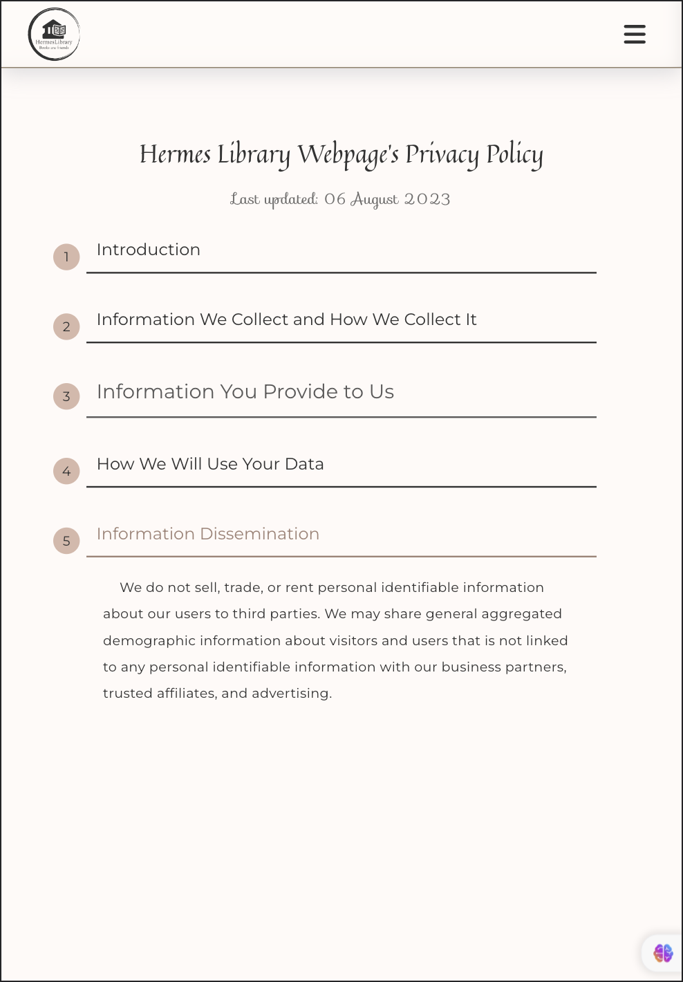

Appendix 6 3 Privacy Page – iPad Air - 1

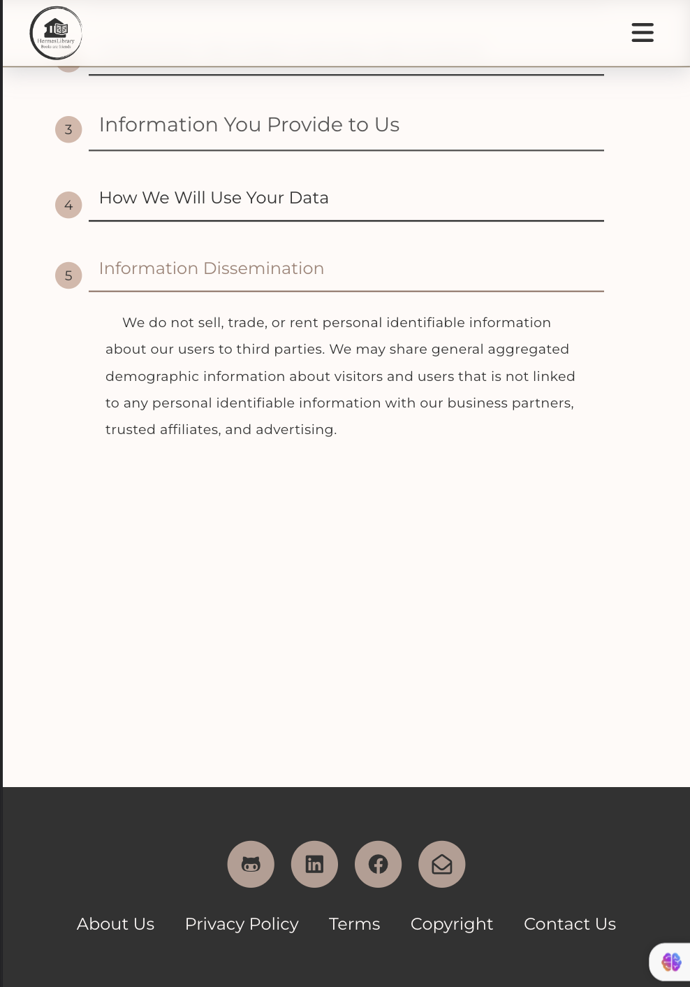

Appendix 6 4 Privacy Page – iPad Air - 2

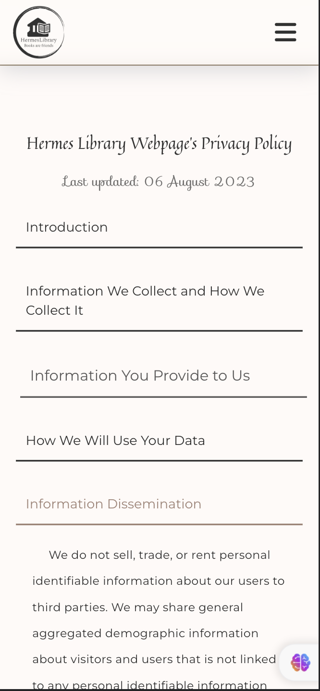

Appendix 6 5 Privacy Page – iPhone 12 Pro - 1

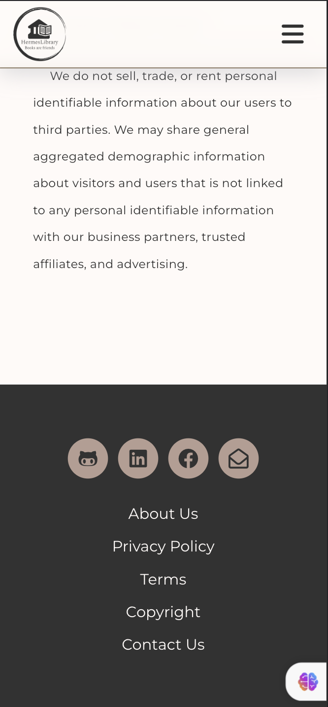

Appendix 6 6 Privacy Page – iPhone 12 Pro - 2

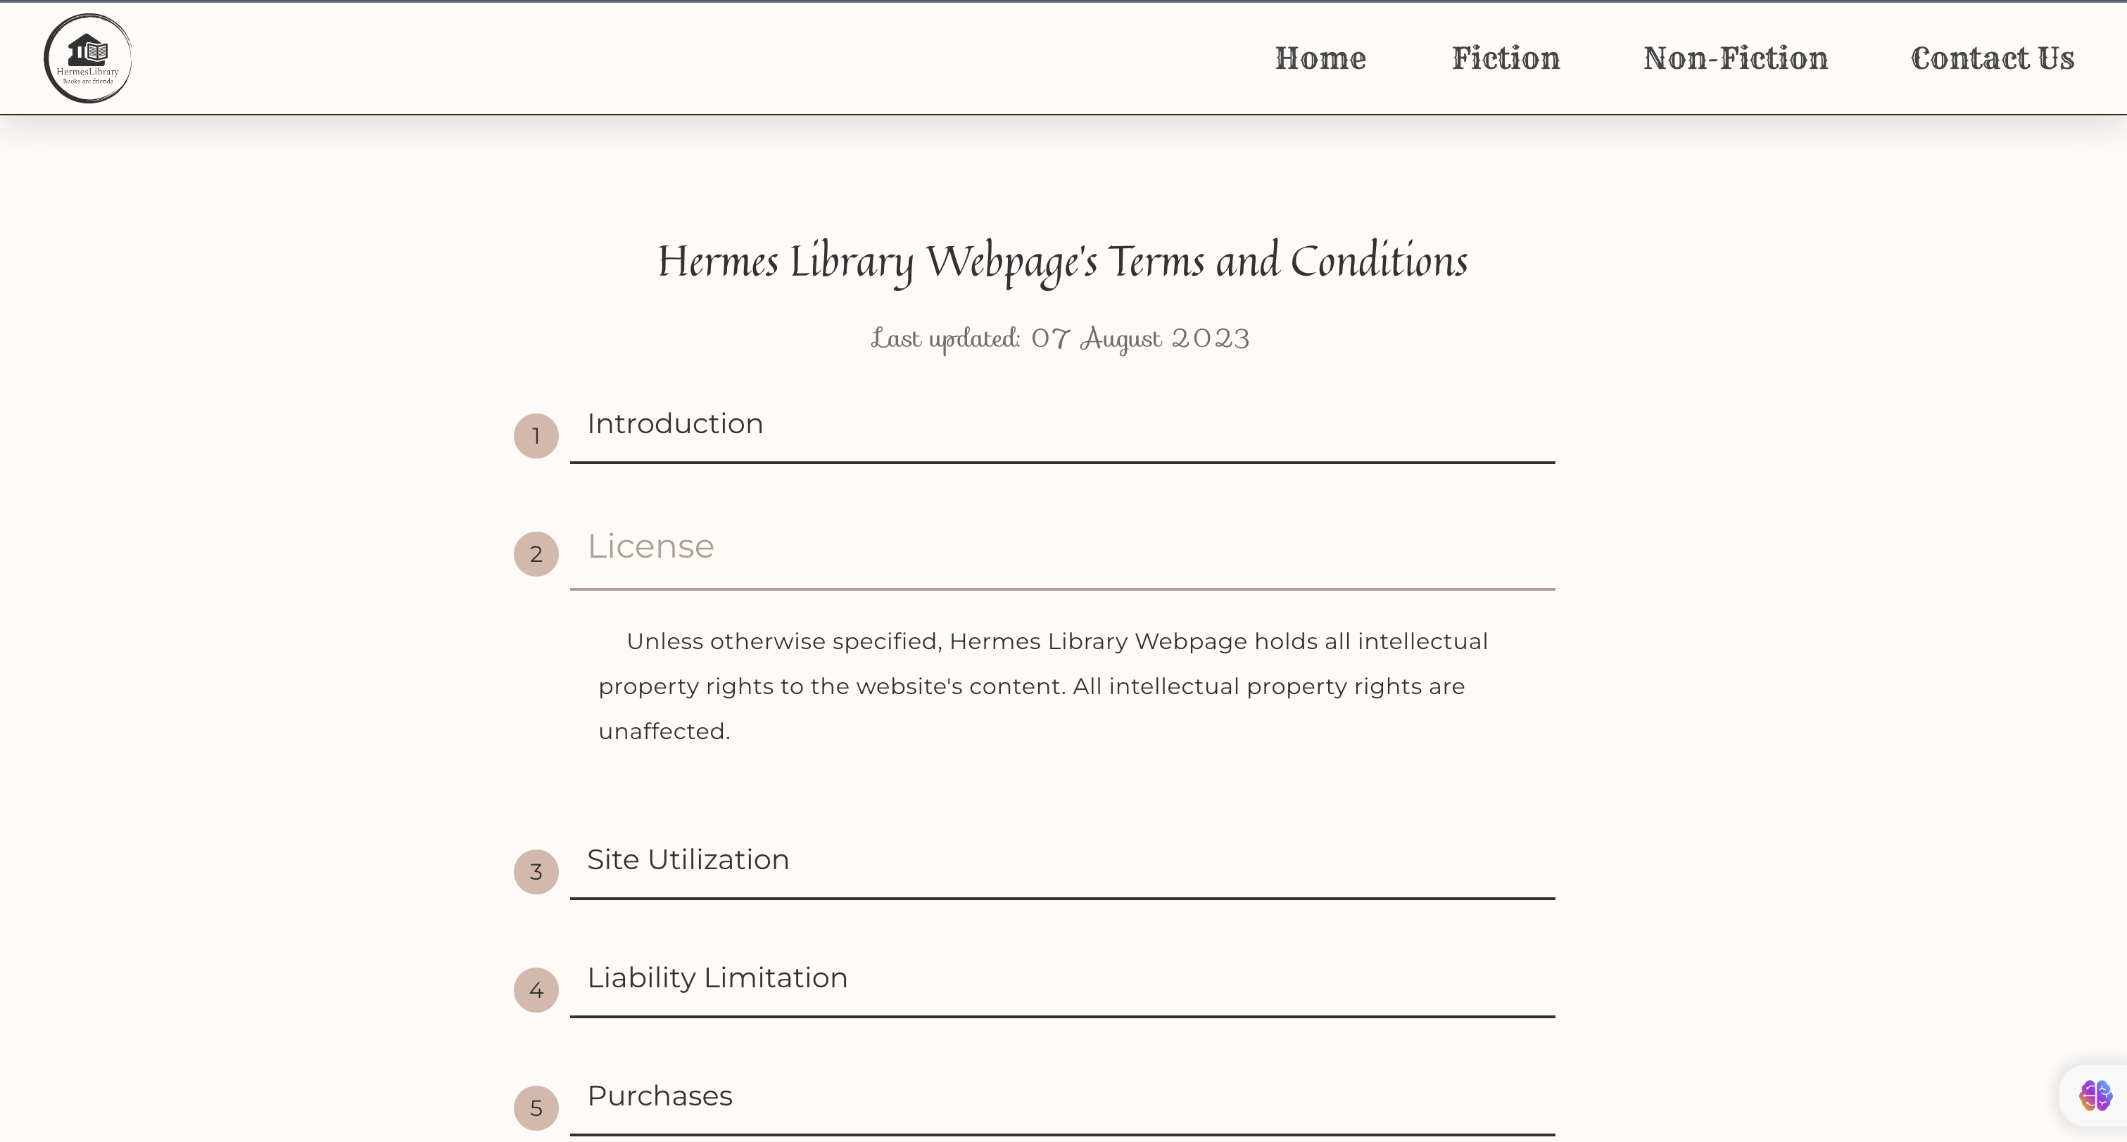

Appendix 6 7 Terms Page – Desktop - 1

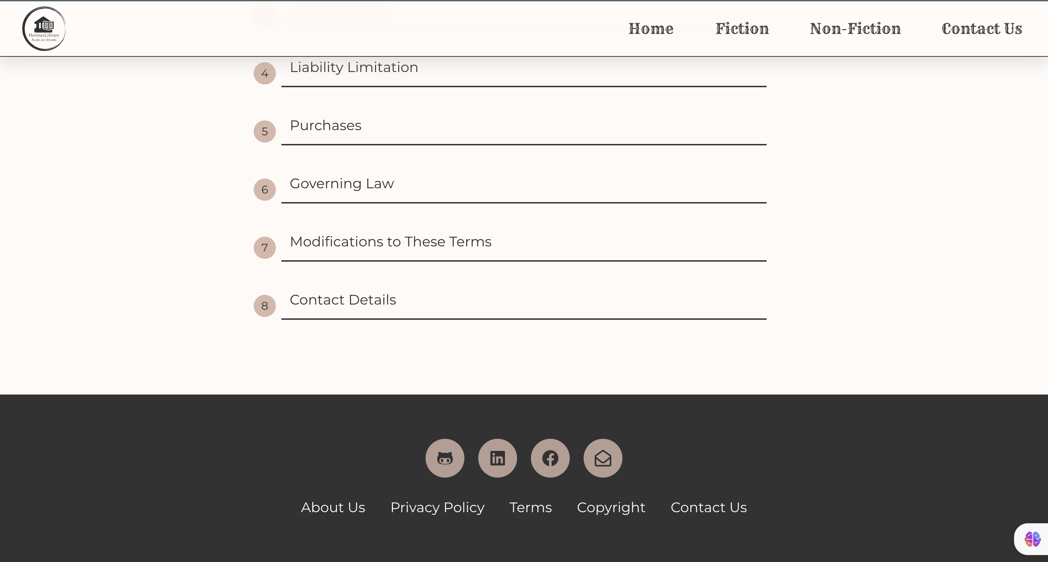

Appendix 6 8 Terms Page – Desktop - 2

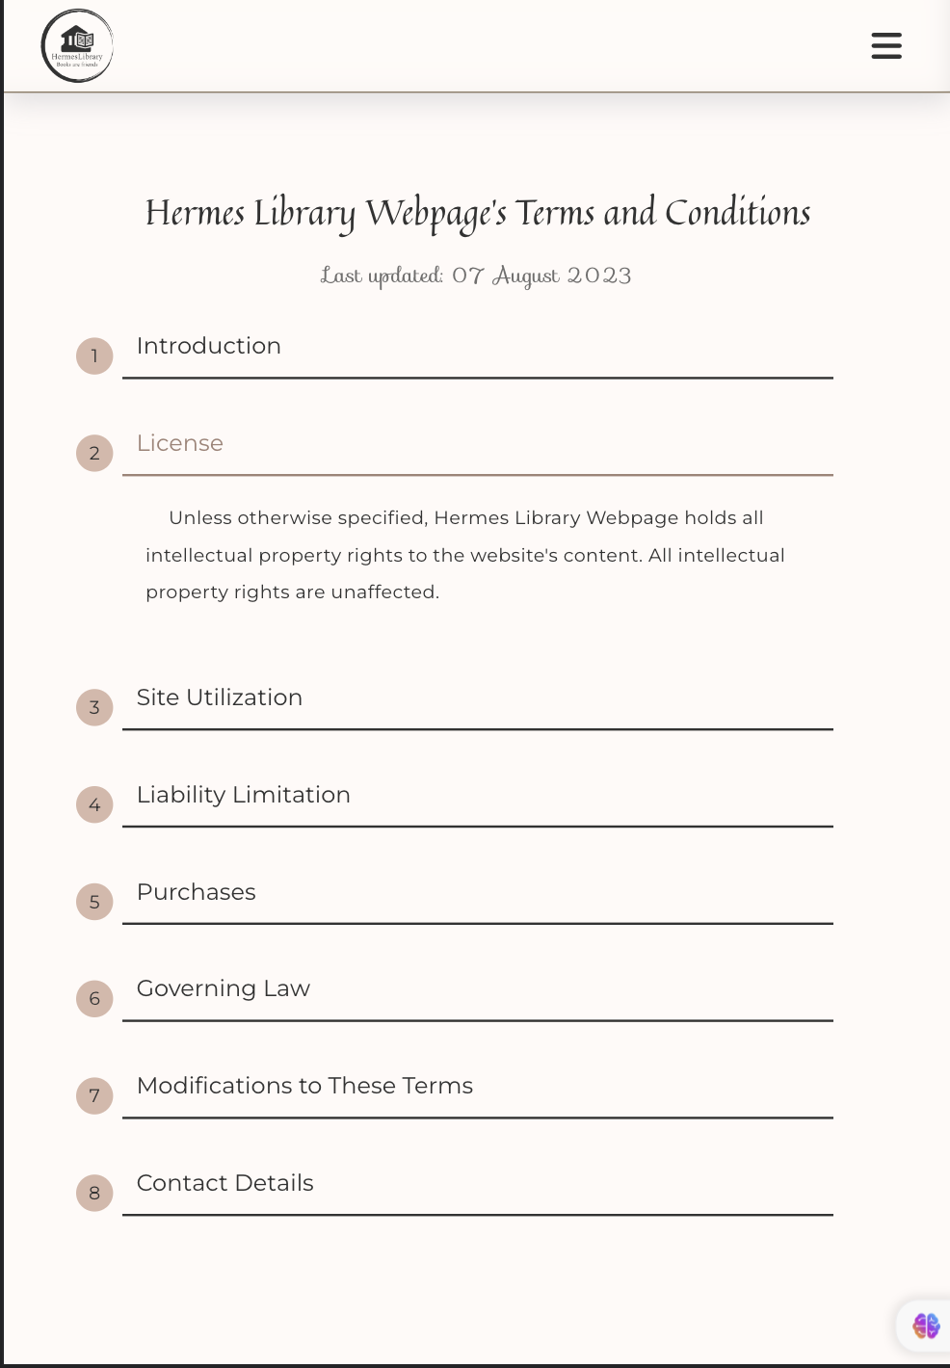

Appendix 6 9 Terms Page – iPad Air - 1

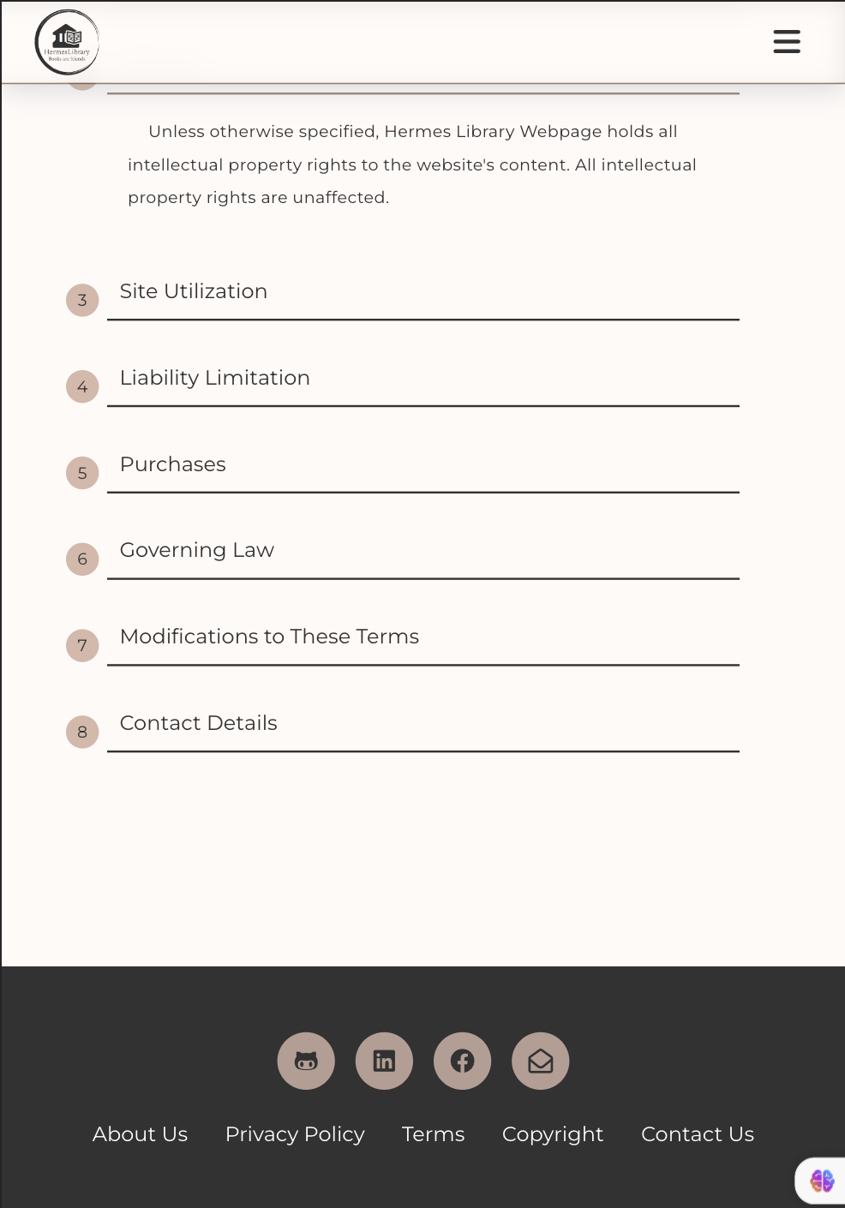

Appendix 6 10 Terms Page – iPad Air - 2

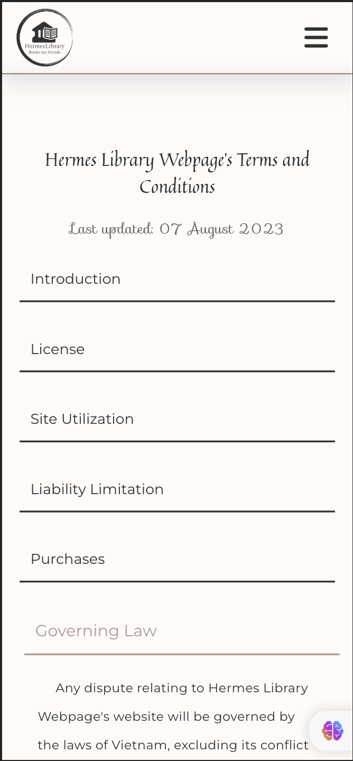

Appendix 6 11 Terms Page – iPhone Pro 12 - 1

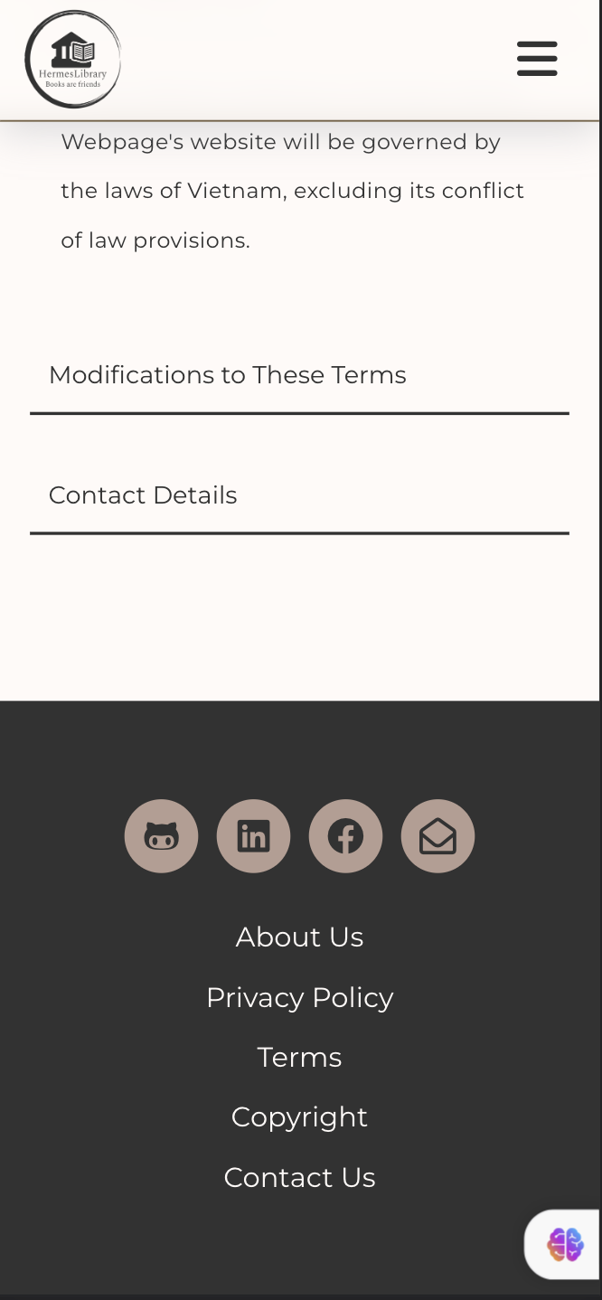

Appendix 6 12 Terms Page – iPhone Pro 12 - 2

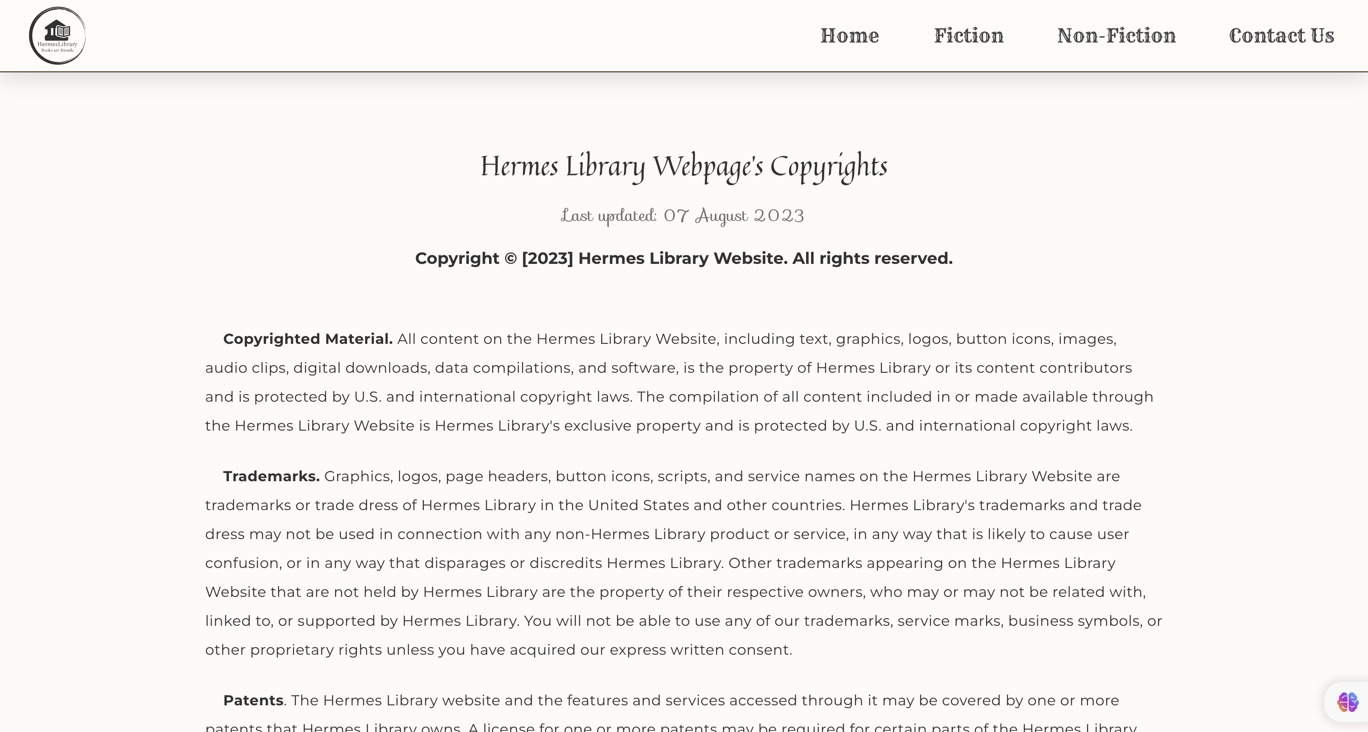

Appendix 6 13 Copyrights Page – Desktop - 1

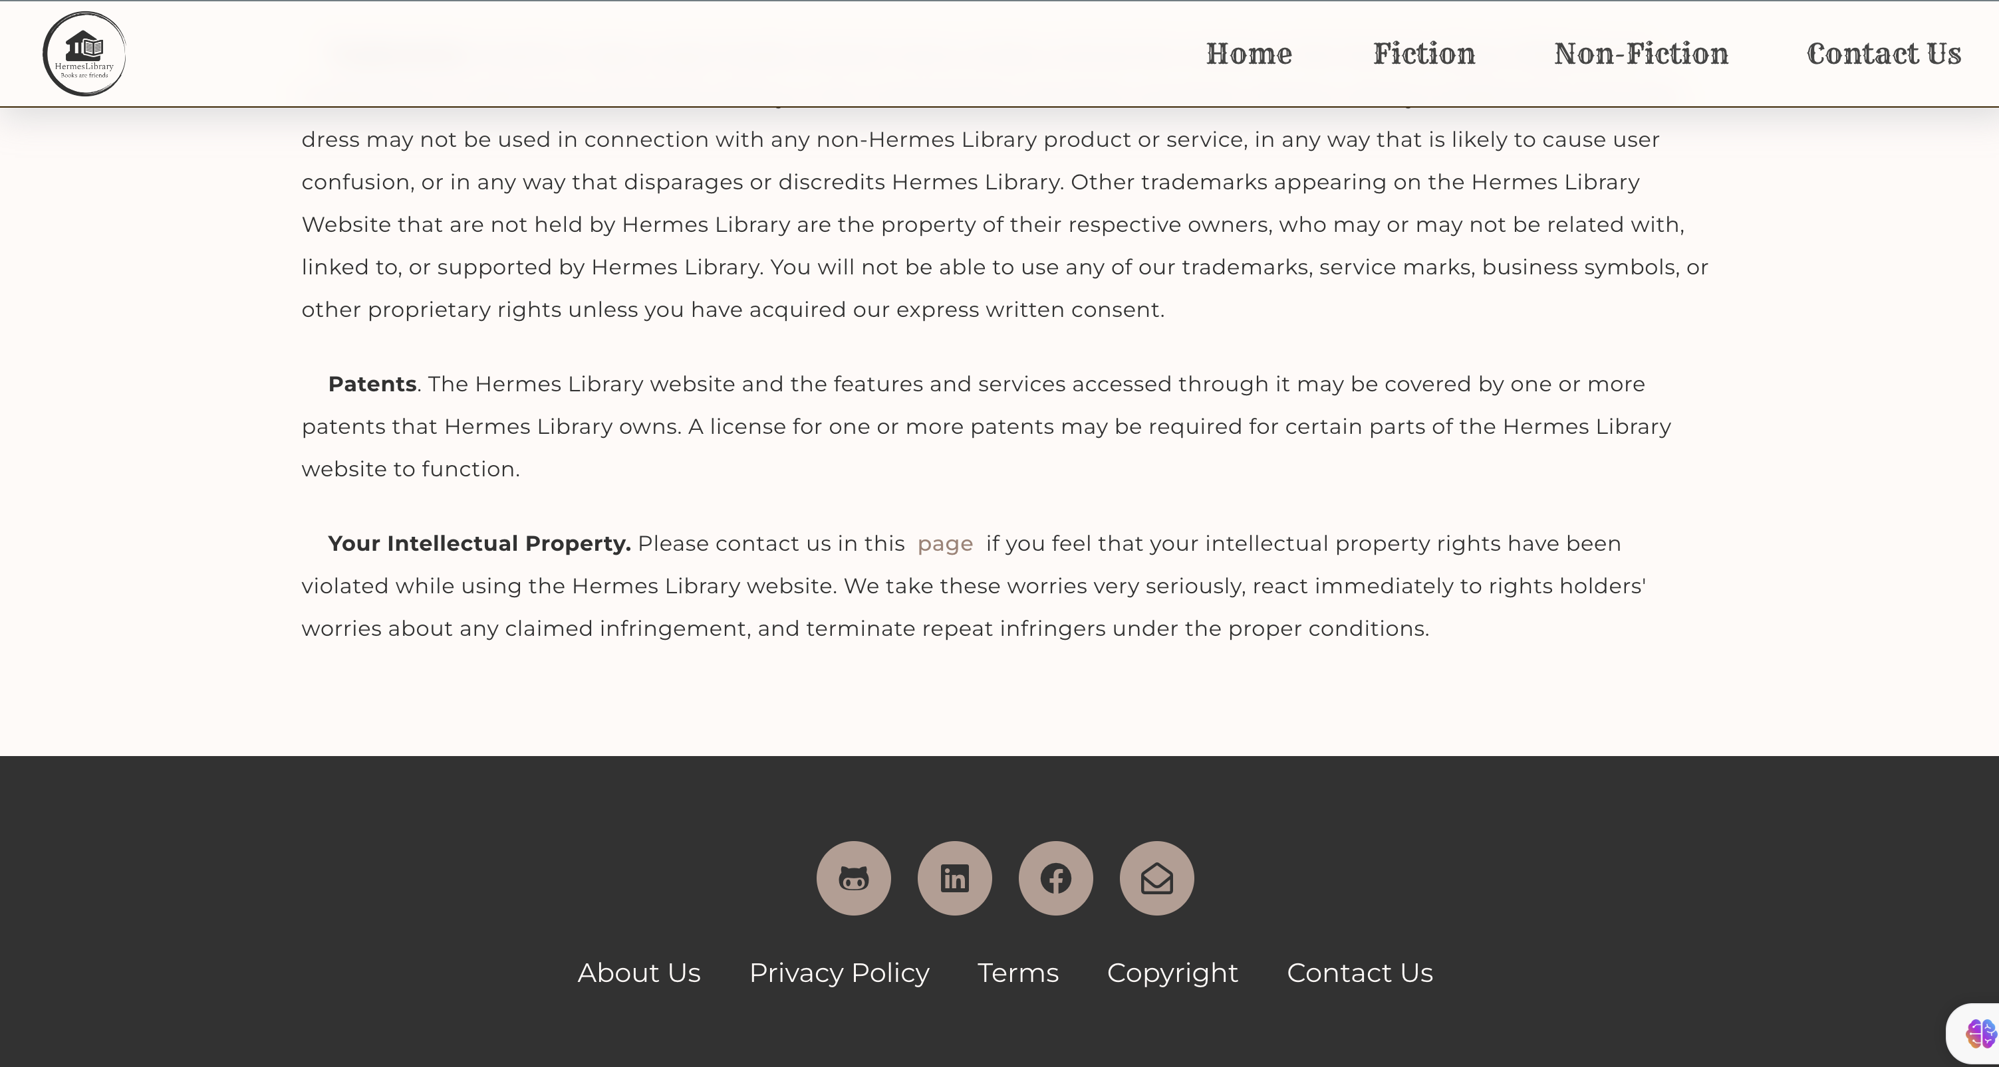

Appendix 6 14 Copyrights Page – Desktop - 2

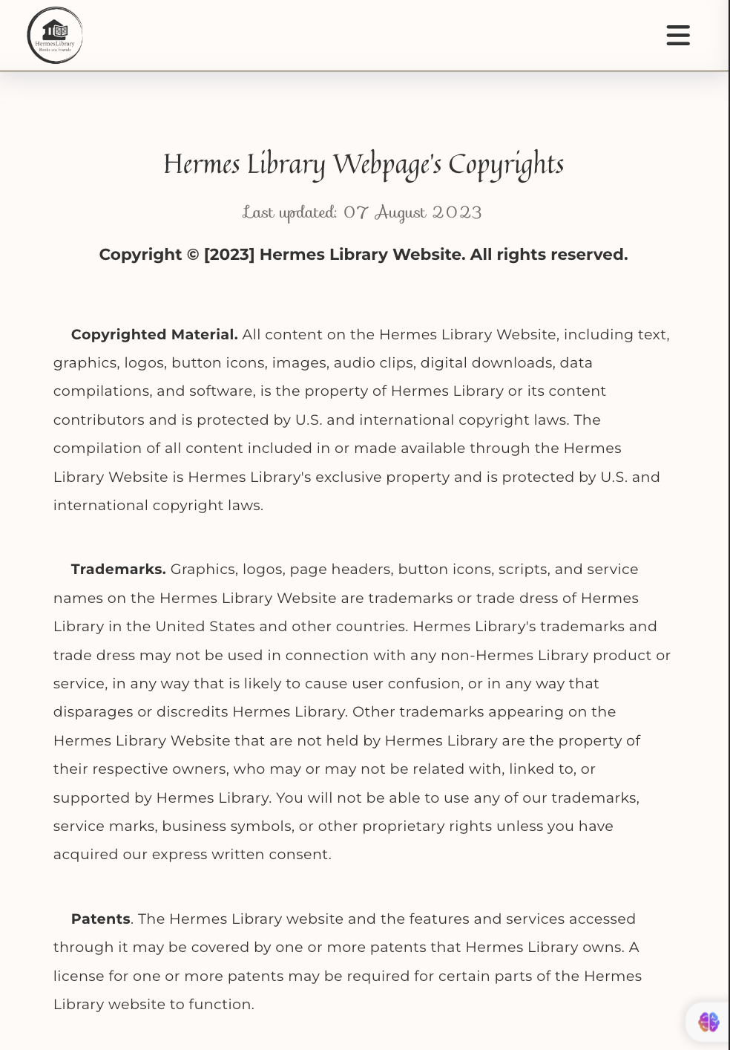

Appendix 6 15 Copyrights Page – iPad Air - 1

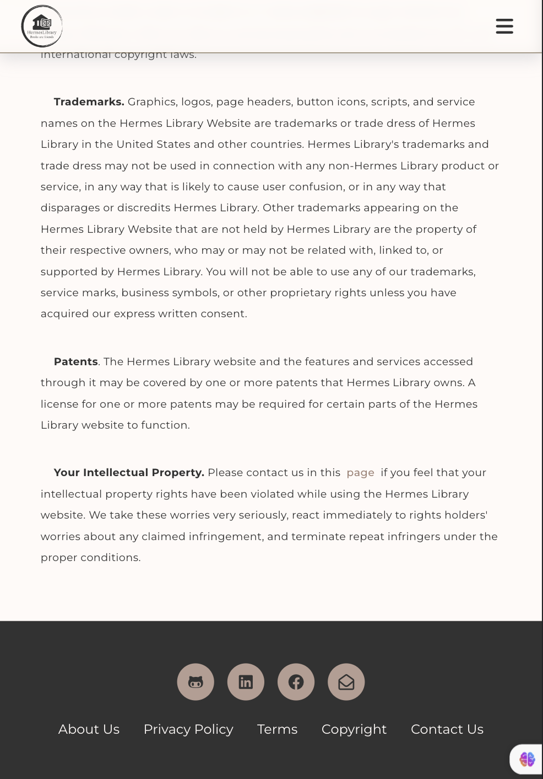

Appendix 6 16 Copyrights Page – iPad Air - 2

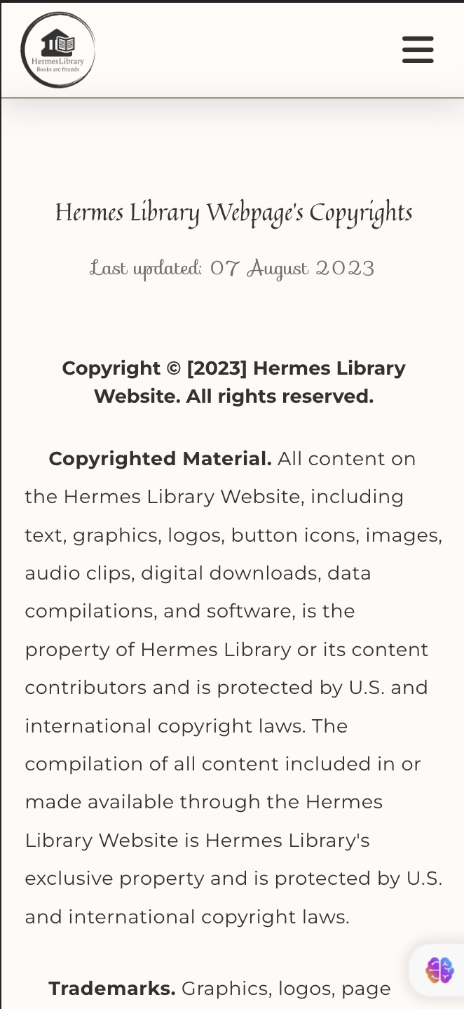

Appendix 6 17 Copyrights Page – iPhone 12 Pro - 1

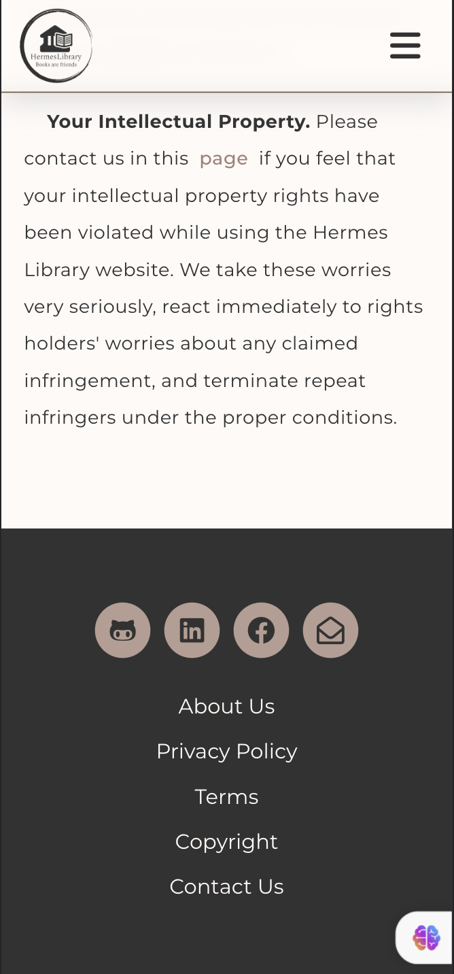

Appendix 6 18 Copyrights Page – iPhone 12 Pro - 2